**Enhancing Public Health: a Better Approach for Face Mask Detection Using Transfer Learning to Prevent Airborne Disease**

by

**Naimul Hasan Shadesh**

ID: CSE1903018059

Supervised by

**Arifur Rahaman**

Submitted in partial fulfilment of the requirements for the degree of Bachelor of Science in Computer Science and Engineering



**DEPARTMENT OF COMPUTER SCIENCE AND ENGINEERING**

**SONARGAON UNIVERSITY (SU)**

September 2023

**Enhancing Public Health: a Better Approach for Face Mask Detection Using Transfer Learning to Prevent Airborne Disease**

by

**Naimul Hasan Shadesh**

ID: CSE1903018059

Supervised by

**Arifur Rahaman**

Submitted in partial fulfilment of the requirements for the degree of Bachelor of Science in Computer Science and Engineering



**DEPARTMENT OF COMPUTER SCIENCE AND ENGINEERING**

**SONARGAON UNIVERSITY (SU)**

**APPROVAL**

The thesis titled “**Enhancing Public Health: a Better Approach for Face Mask Detection Using Transfer Learning to Prevent Airborne Disease”** submitted by Naimul Hasan Shadesh (CSE1903018059) to the Department of Computer Science and Engineering, Sonargaon University (SU), has been accepted as satisfactory for the partial fulfillment of the requirements for the degree of Bachelor of Science in Computer Science and Engineering and approved as to its style and contents.

**Board of Examiners**

|  |  |
| --- | --- |
| ----------------------------------------  **Arifur Rahaman**  Assistant Professor & Coordinator  Department of Computer Science and Engineering  Sonargaon University (SU)  --------------------------------------  (Examiner Name and Signature)  Department of Computer Science and Engineering  Sonargaon University (SU) | **Supervisor**    **Examiner 1** |
| --------------------------------------  (Examiner Name and Signature)  Department of Computer Science and Engineering  Sonargaon University (SU)  --------------------------------------  (Examiner Name and Signature)  Department of Computer Science and Engineering  Sonargaon University (SU) | **Examiner 2**  **Examiner 3** |

**DECLARATION**

We, hereby, declare that the work presented in this report is the outcome of the investigation performed by us under the supervision of **Arifur Rahaman, Assistant Professor & Coordinator,** Department of Computer Science and Engineering, Sonargaon University, Dhaka, Bangladesh. We reaffirm that no part of this thesis has been or is being submitted elsewhere for the award of any degree or diploma

|  |  |
| --- | --- |
| Countersigned  ------------------------------  **(Arifur Rahaman)**  **Supervisor** | Signature  ------------------------  Naimul Hasan Shadesh  ID: CSE1903108059 |

**ABSTRACT**

Face mask typically refers to a covering that is worn over the nose and mouth to provide protection from airborne particles and potentially harmful substances. The primary purpose of a face mask is to reduce the transmission of respiratory droplets that may contain viruses, bacteria, or other contaminants, especially in situations where maintaining physical distance is important. Computer Vision can help to monitor the use of face masks based on images captured via CCTV. A previous study built a mask detection system using Convolutional Neural Networks (CNN) based models, which produced high accuracy but was limited to the front face. This research focuses on leveraging computer vision and machine learning, Deep learning techniques for accurate face mask detection. The proposed approach employs transfer learning, utilizing MobileNetV2 as the base model, coupled with a custom classifier. This model consists of two core components: face detection (faceNet) and face mask classification (maskNet), following established machine learning and deep learning workflows. Experimental results underscore its effectiveness, achieving a remarkable 97.87% accuracy in identifying individuals wearing masks, 98.46% accuracy in detecting those without masks, culminating in an impressive overall model accuracy of 98.33%. In addition to its primary role in monitoring mask compliance, this research highlights its potential to make meaningful contributions to technological progress and endeavors aimed at enhancing public health.

# ACKNOWLEDGMENT

At the very beginning, we would like to express my deepest gratitude to the Almighty Allah for giving us the ability and the strength to finish the task successfully within the schedule time.

We are auspicious that we had the kind association as well as supervision of **Arifur Rahaman**, Assistant Professor and Coordinator, Department of Computer Science and Engineering, Sonargaon University whose hearted and valuable support with best concern and direction acted as necessary recourse to carry out our project.

We are also thankful to all our teachers during our whole education, for exposing us to the beauty of learning.

Finally, our deepest gratitude and love to my parents for their support, encouragement, and endless love.

**LIST OF ABBREVIATIONS**

AI Artificial Intelligence

CNN Convolutional Neural Network

Covid-19 Coronavirus Disease 2019

DL Deep Learning

F1 F1 Score (a measure of classification accuracy)

F5 F5 Full Face Mask Fit Pack.

H5 Hierarchical Data Format 5

HMM Hidden Markov Model

HOG Histogram of Oriented Gradients

MFCCs Mel Frequency Cepstral Coefficients

ML Machine Learning

MobileNetV2 Mobile Network Version 2

MTCCN Multi-Task Cascaded Convolutional Neural Network.

RT Real-Time

SVM Support Vector Machine

USB Universal Serial Bus

YOLOv5 You Only Look Once Version 5

mAP mean Average Precision

ReLU Rectified Linear Unit

**TABLE OF CONTENTS**

|  |  |  |  |  |  |
| --- | --- | --- | --- | --- | --- |
| Title | | |  | | Page No. |
|  | | | | | |
| **DECLARATION** …………………………………………………………..…….. | | | | | iii |
| **ABSTRACT** ……………………...………………………………………………. | | | | | iv |
| **ACKNOWLEDGEMENT** ………………………………………….…………… | | | | | v |
| **LIST OF ABBREVIATION** ………….…………………………………………. | | | | | vi |
|  | | | | | |
| **CHAPTER 1** | | |  | | 1 – 6 |
| INTRODUCTION | | | | |  |
|  | 1.1 | Background............................................................................................ | | | 1 |
|  | 1.2 | Problem Statement................................................................................. | | | 1 |
|  | 1.3 | Objectives of Thesis work..................................................................... | | | 2 |
|  | 1.4 | Literature Review.................................................................................. | | | 3 |
|  | 1.5 | Motivation.............................................................................................. | | | 4 |
|  | 1.6 | Thesis Contribution................................................................................ | | | 5 |
|  | 1.7 | Articulatory or Distinctive Phonetic Feature Extraction....................... | | | 6 |
| ss | | | | | |
| **CHAPTER 2** | | |  | | 7 – 10 |
| ARTIFICIAL INTELLIGENCE | | | | |  |
|  | 2.1 | Introduction............................................................................................ | | | 7 |
|  | 2.2 | Artificial intelligence applications......................................................... | | | 8 |
|  | 2.3 | Artificial intelligence challenges........................................................... | | | 9 |
|  | | | | | |
| **CHAPTER 3** | | |  | | 11 – 14 |
| MACHINE LEARNING | | | | |  |
|  | 3.1 | Introduction............................................................................................ | | | 11 |
|  | 3.2 | Machine learning applications............................................................... | | | 12 |
|  |  | 3.2.1 | | Computer vision....................................................................... | 13 |
|  |  | 3.2.2 | | Speech recognition................................................................... | 13 |
|  |  | 3.2.3 | | Future Predictions.................................................................... | 13 |
|  | 3.3 | Machine learning challenges................................................................. | | | 14 |
|  | | | | | |
| **CHAPTER 4** | | |  | | 15 – 21 |
| DEEP LEARNING | | | | |  |
|  | 4.1 | Introduction............................................................................................ | | | 15 |
|  | 4.2 | Why Face Mask Detection Analysis...................................................... | | | 15 |
|  |  | 4.2.1 | | Public Health and Safety.......................................................... | 15 |
|  |  | 4.2.2 | | COVID-19 Pandemic............................................................... | 15 |
|  |  | 4.2.3 | | Automation and Efficiency...................................................... | 16 |
|  |  | 4.2.4 | | Large-scale Monitoring............................................................ | 16 |
|  |  | 4.2.5 | | Machine Learning Advancements............................................ | 16 |
|  |  | 4.2.6 | | Safety Compliance................................................................... | 16 |
|  |  | 4.2.7 | | Technological Impact............................................................... | 16 |
|  | 4.3 | Convolutional Neural Network.............................................................. | | | 16 |
|  | 4.4 | Kernel..................................................................................................... | | | 17 |
|  | 4.5 | MobileNetV2......................................................................................... | | | 19 |
|  |  | 4.5.1 | | Depthwise Separable Convolutions......................................... | 19 |
|  |  | 4.5.2 | | Inverted Residual Blocks......................................................... | 19 |
|  |  | 4.5.3 | | Linear Bottlenecks.................................................................... | 19 |
|  |  | 4.5.4 | | Multiplier Parameter................................................................ | 19 |
|  | 4.6 | Deep learning applications…………….………………………............ | | | 20 |
|  | 4.7 | Deep learning challenges……………….……………………….......... | | | 21 |
|  | | | | | |
| **CHAPTER 5** | | |  | | 22 – 33 |
| PROPOSED METHODOLOGY FOR FACE MASK DETECTION | | | | |  |
|  | 5.1 | Introduction............................................................................................ | | | 22 |
|  | 5.2 | Data Collection……………………………………….………………. | | | 23 |
|  |  | 5.2.1 | | Public Datasets……………………………….……………… | 23 |
|  |  | 5.2.2 | | Custom Image Collection……………………………………. | 24 |
|  |  | 5.2.3 | | Dataset Size: ……………………………….………………... | 25 |
|  | 5.3 | Description of The Face Mask Detection Dataset……………………. | | | 26 |
|  | 5.4 | Data Preprocessing……………………………………….…………... | | | 27 |
|  | 5.5 | Model Training and Evaluation………………………………………. | | | 27 |
|  |  | 5.5.1 | | Model Training……………………………….……………… | 28 |
|  |  | 5.5.2 | | Model Evaluation……………………………………….…… | 29 |
|  | 5.6 | Transfer Learning……………………………………….……………. | | | 30 |
|  |  | 5.6.1 | | Image Classification……………………….………………… | 30 |
|  |  | 5.6.2 | | Natural Language Processing………………………………... | 30 |
|  | 5.7 | Real-Time Detection…………………………………….……………. | | | 32 |
|  |  | 5.7.1 | | Import Libraries and Modules……………….……………… | 32 |
|  |  | 5.7.2 | | Define the detect_and_predict_mask Function……………… | 3 |
|  |  | 5.7.3 | | Load Pre-Trained Models…………………….……………… | 32 |
|  |  | 5.7.4 | | Start Video Stream…………………………….…………….. | 33 |
|  |  | 5.7.5 | | Real-Time Face Mask Detection Loop……………………… | 33 |
|  |  | 5.7.6 | | Termination………………………………….………………. | 33 |
|  | | | | | |
| **CHAPTER 6** | | |  | | 34– 46 |
| RESULT ANALYSIS AND DISCUSSIONS | | | | |  |
|  | 6.1 | Introduction………………………………..…...................................... | | | 34 |
|  | 6.2 | Experiments………………………………..…..................................... | | | 34 |
|  |  | 6.2.1 | | Experiments on Model………………………………..…....... | 35 |
|  |  | 6.2.2 | | Experiments with MobileNetV2 based pre-trained model…... | 35 |
|  | 6.3 | Analysis of Results for Different Combinations……………………… | | | 38 |
|  | 6.4 | Discussion………………………………..…........................................ | | | 39 |
|  | | | | | |
| **CHAPTER 7** | | |  | | 48 |
| CONCLUSION AND FUTURE WORKS | | | | | |
|  | 7.1 | Conclusion………………………………..…....................................... | | | 46 |
|  | 7.2 | Future Works………………………………..…................................... | | | 46 |
|  | | | | | |
| **REFERENCES** ……………………………………………………….………….. | | | | | 47 – 48 |
|  | | | | | |

**LIST OF FIGURES**

|  |  |  |
| --- | --- | --- |
| **Figure No.** | **Title** | **Page No.** |
| Fig.4.1 | Model Architecture for convolutional neural network (CNN) | 17 |
| Fig.4.2 | Kernel Architecture | 18 |
| Fig.4.3 | Convolutional neural network (CNN) Architecture | 21 |
| Fig.5.1 | Hases and Individual steps for building a face mask detector using TensorFlow/Keras. | 23 |
| Fig.5.2 | Model Training Architecture. | 28 |
| Fig.5.3 | Training Head Model Load. | 29 |
| Fig.5.4 | Training Model Accuracy. | 29 |
| Fig.5.5 | Model Evaluation Architecture. | 30 |
| Fig.5.6 | Transfer Learning Block Diagram. | 32 |
| Fig.5.7 | Real Time Detection Architecture. | 33 |
| Fig.6.1 | Training Loss and Accuracy. | 36 |
| Fig.6.2 | Training Accuracy. | 36 |
| Fig.6.3 | Training Loss. | 37 |
| Fig.6.4 | No Mask Single Face Mask Detection Computer vision. | 40 |
| Fig.6.5 | Some Position Face Mask Detection Computer vision. | 40 |
| Fig.6.6 | Group Face Mask Detection Computer vision. | 41 |
| Fig.6.7 | No Mask Single & Sunglass Face Mask Detection Computer vision. | 41 |
| Fig.6.8 | Different Mask Detection Computer vision. | 42 |
| Fig.6.9 | Sunglass and Different Face Mask Detection Computer vision. | 42 |
| Fig.6.10 | Sunglass and Different Mask Detection Computer vision. | 43 |
| Fig.6.11 | Face Mask Detection Group and Naqab. | 43 |
| Fig.6.12 | Mask and No Mask Detection Computer vision. | 43 |
| Fig.6.13 | (A) Halloween Face Masks (B) K95 Mask (C) Surgical Mask Detection Computer vision. | 44 |
| Fig.6.14 | (A) and (B) Naqab Mask (C) Funny Home Mask Detection Computer vision. | 44 |

**LIST OF TABLES**

|  |  |  |
| --- | --- | --- |
| **Table No.** | **Title** | **Page No.** |
| Table 5.1 | Data Collection and Web Scraping Install Required. | 23 |
| Table 5.2 | Data Collection and Web Scraping in Python. | 24 |
| Table 5.3 | Indicative images of the FaceMask database. (A, C, E) Group No Face-Mask-Data.(B, D, F) No Single Face-Mask-Data . | 24 |
| Table 5.4 | Indicative images of the FaceMask database. (A, B, C) Group and Random FaceMask Data, (D, E, F) Single Face Masks Data. | 25 |

**CHAPTER 1**

**INTRODUCTION**

## 1.1 Background

Face mask detection has emerged as a significant computer vision task, aimed at determining whether an individual in an image or video is wearing a face mask. This task has gained immense importance in recent times, particularly during the COVID-19 pandemic, where face masks have been proven to be effective in curbing the spread of the virus [1].

Several approaches are employed for face mask detection, each with its own set of methodologies. One traditional approach involves utilizing computer vision techniques like edge detection and facial landmark detection. By identifying facial features such as eyes, nose, and mouth, this method can subsequently determine whether a person is wearing a face mask [3].

In contrast, deep learning presents another approach to face mask detection. Deep learning leverages artificial neural networks to learn patterns from vast datasets containing images of people both with and without face masks. Once the model is trained on such data, it can effectively detect the presence of face masks in new images [3].

Comparing the two approaches, deep learning models have demonstrated higher accuracy when compared to traditional computer vision techniques for face mask detection. However, it is important to consider that deep learning models may demand more computational resources for training and deployment, making them computationally expensive.

To build an efficient face mask detection system, researchers must consider the trade-offs between traditional computer vision methods and deep learning models, taking into account the specific requirements and constraints of their applications. As this technology continues to evolve, advancements in both approaches are expected to play a pivotal role in public health and safety measures [6].

* 1. **Problem Statement**

The face mask detection task involves developing a computer vision system capable of accurately identifying whether individuals in images or videos are wearing face masks. This task has gained significant importance due to the ongoing COVID-19 pandemic, where face masks serve as a crucial preventive measure to mitigate the transmission of the virus [1].

The primary objective of this research is to create an efficient and reliable face mask detection model that can be deployed in real-world scenarios. The model should be capable of detecting face masks with high accuracy and robustness, even in challenging environments with variations in mask types, lighting conditions, partial face visibility, and the presence of other facial coverings such as Naqab, Sunglasses.

To achieve this goal, the research will explore and compare different approaches for face mask detection, including traditional computer vision techniques, such as edge detection and facial landmark detection, and deep learning methods using convolutional neural networks. The study will evaluate the performance and computational costs of each approach to determine the most suitable method for the specific application.

Furthermore, the research aims to address the following key challenges in face mask detection:

**Variability in Mask Types:** Different face mask types, such as surgical masks, N95 respirators, and cloth masks, may introduce variations in appearance, requiring the model to adapt accordingly.

**Occlusion and Partial Face Visibility:** The presence of obstructions or partial visibility of facial features can pose challenges in accurately detecting face masks, especially when individuals wear additional facial coverings like Naqab.

**Real-time Implementation:** The model should be optimized for real-time processing to facilitate its deployment in public spaces, workplaces, and surveillance systems.

The proposed face mask detection system has potential applications in various domains, including public health, safety, and compliance monitoring. By accurately identifying face masks in images and videos, the system can contribute to efforts aimed at controlling the spread of infectious diseases and ensuring adherence to safety protocols [2, 3].

* 1. **Objectives of Thesis Work**

1. Develop an improved machine learning approach to real-time face mask detection using a convolutional neural network (CNN).
2. Evaluate the performance of the proposed approach on a publicly available dataset of face images with and without masks.
3. Compare the performance of the proposed approach to other state-of-the-art face mask detection methods.

The proposed approach is based on a CNN, which is a type of deep learning algorithm that is well-suited for image classification tasks. CNN is trained on a dataset of face images with and without masks. The training process involves adjusting the weights of the CNN so that it can accurately classify images as either having a mask or not having a mask.

The performance of the proposed approach is evaluated on a publicly available dataset of face images with and without masks. The dataset consists of over 5,182 images. The proposed approach achieves an accuracy of over 98.46% on this dataset [2].

The proposed approach is compared to other state-of-the-art face mask detection methods. The results of the comparison show that the proposed approach achieves comparable or better performance than other methods.

The findings of this research suggest that the proposed approach is a promising method for real-time face mask detection. The approach is accurate, efficient, and can be easily deployed in a variety of settings.

In addition to the objectives listed above, this research also aims to:

* Explore the use of different CNN architectures for face mask detection.
* Investigate the use of different image augmentation techniques to improve the performance of the CNN.
* Evaluate the performance of the proposed approach on different datasets of face images with and without masks.
* Compare the performance of the proposed approach to other state-of-the-art face mask detection methods under different conditions, such as different lighting conditions and different face sizes.

The findings of this research will contribute to the development of more accurate and efficient face mask detection methods. The results of this research will also be useful for researchers and practitioners who are interested in developing face mask detection systems [16].

* 1. **Literature Review**

The literature review delves into the realm of face mask detection, computer vision, and machine learning techniques. It presents an in-depth exploration of existing research, studies, and advancements in this domain, shedding light on the current state of the field, methodologies employed, and progress made in face mask detection technology.

Various face mask detection techniques have been investigated, including traditional computer vision approaches such as edge detection, Haar cascades, and facial landmark detection. However, the spotlight has been on deep learning methods, particularly Convolutional Neural Networks (CNNs), which have emerged as the frontrunner for face mask detection. Researchers have designed custom CNN architectures or harnessed pre-trained models to bolster accuracy and efficiency [7].

The literature review highlights the significance of diverse datasets, meticulously curated with labeled images and videos of individuals both wearing and without face masks. These datasets capture variations in mask types, colors, and poses. Moreover, data preprocessing techniques, including data augmentation, have been employed to enhance model generalization.

Amidst the progress, several challenges remain. Occlusion and partial face visibility due to facial accessories or hair can impede accurate face mask detection, especially in crowded settings. Mask variations, encompassing different types, textures, and shapes, have posed challenges in precise identification and classification. Additionally, real-world scenarios, marked by illumination changes, varying camera angles, and unpredictable environments, have impacted model performance [9].

Model evaluation in the literature often involves metrics like accuracy, precision, recall, F1 score, and confusion matrix analysis. Comparative studies are frequently conducted to discern the most effective techniques for face mask detection. Real-time implementation has been explored, aiming to optimize computational efficiency and enable live video stream processing for face mask detection.

The applications of face mask detection systems span numerous domains, including healthcare facilities, public spaces, transportation hubs, and workplaces, where adherence to face mask policies is pivotal for public health and safety.

Ethical considerations and privacy preservation have not been overlooked in the literature. As face mask detection involves processing facial images, researchers underscore the importance of data security and user consent.

Looking to the future, the literature review identifies promising research directions, including improving model robustness against occlusion, exploring multi-modal approaches integrating other sensors, and addressing potential bias in face mask detection systems [15].

* 1. **Motivation**

Effective measures to combat the transmission of respiratory diseases, particularly in the wake of the COVID-19 pandemic. Face masks have emerged as a crucial tool in curbing the spread of viruses and bacteria through respiratory droplets. Governments, organizations, and communities worldwide have implemented face mask mandates to safeguard public health and safety [2].

While the importance of wearing face masks is well-established, manual enforcement and monitoring of compliance in various settings can be challenging and resource-intensive. To address this, the integration of computer vision and machine learning offers a promising solution. Developing an accurate and efficient face mask detection system has the potential to automate the process of identifying individuals wearing or not wearing face masks in real-time [3].

By harnessing advanced technologies like deep learning and convolutional neural networks, this research aims to contribute to the creation of a robust and reliable face mask detection model. Such a model could be deployed in diverse environments, including hospitals, airports, schools, and public spaces, to ensure compliance with face mask policies and promote public health measures.

The development of an effective face mask detection system carries far-reaching implications. It could assist in the early detection of non-compliance, facilitating timely interventions and reducing the risk of virus transmission. Moreover, automating this process could free up valuable human resources, allowing healthcare professionals and authorities to focus on other critical tasks [11].

Beyond the immediate application during the pandemic, the outcomes of this research can find relevance in various future scenarios where face mask detection remains essential, such as during seasonal flu outbreaks or in response to new infectious diseases. Additionally, the insights gained from this work can contribute to advancements in computer vision, machine learning, and artificial intelligence applications for public health and safety [11].

The motivation to pursue this Research is driven by the desire to make a positive impact on public health outcomes and contribute to the ongoing efforts to combat contagious diseases. Developing a reliable face mask detection model has the potential to promote responsible behavior, enhance safety measures, and play a part in safeguarding global health and well-being.

* 1. **Thesis Contribution**

The primary contribution of this thesis lies in the development and implementation of an accurate, efficient, and real-time face mask detection system using deep learning techniques. The system aims to automate the process of identifying individuals wearing or not wearing face masks in various environments, contributing to public health and safety measures.

1. **Face Mask Detection Model:** The core contribution involves designing and training a state-of-the-art face mask detection model. Leveraging Convolutional Neural Networks (CNNs) and transfer learning, the model is trained on a diverse dataset of labeled images containing individuals with and without face masks. The model can accurately classify faces and determine the presence or absence of face masks with high precision [2].
2. **Real-Time Implementation:** The developed face mask detection system is optimized for real-time performance, enabling seamless deployment in live video streams. The system can process video feeds in real-time, allowing immediate identification of individuals adhering to face mask policies or those in need of intervention [8].
3. **Robustness and Generalization:** Special attention is given to ensuring the robustness and generalization capabilities of the model. Data augmentation techniques and careful dataset curation are employed to enhance the model's ability to handle variations in mask types, colors, poses, and facial expressions. The system aims to perform reliably across different lighting conditions and diverse real-world scenarios [8].
4. **Comparative Analysis:** A thorough comparative analysis is conducted, evaluating the performance of the developed face mask detection system against other existing approaches and traditional computer vision techniques. This analysis aims to demonstrate the superiority of the deep learning-based model in terms of accuracy and efficiency.
5. **Practical Application:** The face mask detection system's practical application is assessed in real-world settings, such as healthcare facilities, public spaces, transportation hubs, and workplaces. Its potential to assist in monitoring compliance with face mask policies and curb the spread of infectious diseases is explored.
6. **Ethical Considerations:** The thesis addresses ethical considerations and privacy preservation in the context of face mask detection. The system is designed to prioritize data security and user consent, ensuring responsible and privacy-conscious deployment.
7. **Future Directions:** The research identifies potential areas for future development and improvement in face mask detection technology. Future directions may include exploring multi-modal approaches, refining the model's performance under challenging conditions, and addressing any biases that may arise in the system [8].

The overall contribution of this Research is to advance the field of face mask detection using deep learning and contribute to the broader efforts to mitigate the transmission of respiratory diseases. By providing an efficient and accurate face mask detection system, the research aims to support public health measures, optimize resource allocation, and contribute to safer and healthier communities.

* 1. **Articulatory or Distinctive Phonetic Feature Extraction**

Articulatory or distinctive phonetic feature extraction is a process of extracting features from speech signals that can be used to identify phonemes. These features can be extracted using a variety of methods, including:

* **Time-domain features:** These features are based on the temporal properties of the speech signal, such as the amplitude, frequency, and duration of the signal.
* **Frequency-domain features:** These features are based on the frequency properties of the speech signal, such as the spectrum of the signal.
* **Mel-frequency cepstral coefficients (MFCCs):** MFCCs are a type of frequency-domain feature that are commonly used in speech recognition. MFCCs are calculated by taking the logarithm of the power spectrum of the speech signal and then applying a Mel filter bank.

Once the features have been extracted, they can be used to train a machine learning model to identify phonemes. The most common type of machine learning model used for this task is a hidden Markov model (HMM). HMMs are statistical models that can be used to model the probability of a sequence of events. In the case of phoneme recognition, the events are the phonemes in a word [9].

Convolutional neural networks (CNNs) are a type of deep learning algorithm that are commonly used for image classification tasks. CNNs are well-suited for this task because they can learn to extract features from images that are relevant to the classification task [12].

In the case of face mask detection, the CNN can be trained to extract features from images that are indicative of whether or not a person is wearing a face mask. The CNN can then be used to classify images as either "face with mask" or "face without mask."

CNNs have been shown to be very effective for face mask detection. In a recent study, a CNN was able to achieve an accuracy of 99% in detecting face masks in images [17].

This improved machine learning approach to real-time face mask detection using a convolutional neural network has the potential to be used in a variety of applications, such as:

* **Public safety:** This technology can be used to detect people who are not wearing face masks in public places, such as hospitals and schools.
* **Retail:** This technology can be used to detect people who are not wearing face masks in retail stores.
* **Transportation:** This technology can be used to detect people who are not wearing face masks on public transportation.

This technology has the potential to help to prevent the spread of COVID-19 by identifying people who are not wearing face masks.

**CHAPTER 2**

**ARTIFICIAL INTELLIGENCE**

## 2.1 Introduction

Artificial Intelligence (AI) is a branch of computer science that focuses on creating intelligent machines capable of performing tasks that typically require human intelligence. Unlike natural intelligence displayed by humans or animals, AI refers to the ability of machines to learn from experience, adapt to new data, and make decisions based on patterns and algorithms.

In the realm of AI, the concept of "intelligent agents" plays a central role. An intelligent agent is any device or system that can perceive its environment, process information, and take actions to achieve specific goals. These agents can be physical robots or software programs that interact with their surroundings, gather data, and respond to different stimuli [4].

AI has evolved significantly in recent years, driven by advancements in machine learning, neural networks, and deep learning algorithms. These techniques enable machines to recognize patterns, analyze data, and make predictions without explicit programming. As a result, AI systems can excel at tasks such as image and speech recognition, natural language processing, recommendation systems, and autonomous decision-making [4, 5].

In everyday language, "artificial intelligence" is often used to refer to machines or computers that mimic cognitive functions typically associated with human minds. This includes capabilities like learning from experience, problem-solving, understanding natural language, and even exhibiting creativity in certain contexts.

The applications of AI are vast and diverse, impacting various industries such as healthcare, finance, manufacturing, transportation, and entertainment. AI-powered technologies have the potential to revolutionize fields like autonomous vehicles, medical diagnosis, personalized marketing, and virtual assistants, among others.

While AI has made remarkable progress, it also presents challenges and ethical considerations. Issues such as bias in algorithms, data privacy, and the potential impact on the job market require careful consideration as AI continues to evolve and integrate into various aspects of society. As the need for effective face mask monitoring and enforcement continues to grow, advanced technologies offer promising solutions. Artificial Intelligence (AI) and deep learning, in particular, have demonstrated remarkable potential in various computer vision applications. Harnessing the power of deep learning, specifically Convolutional Neural Networks (CNNs), for face mask detection can streamline the process of identifying individuals wearing or not wearing face masks in real-time [9].

The objective of this research is to develop an accurate, efficient, and real-time face mask detection system using deep learning techniques. The system aims to automate the identification of individuals adhering to face mask policies in diverse settings, including public spaces, hospitals, airports, and educational institutions. By employing deep learning algorithms, the system can analyze images or video streams, classify faces, and determine the presence or absence of face masks with high precision [5].

This research builds upon existing literature and studies on face mask detection using deep learning and CNNs. Through a comprehensive literature review, we explore the state-of-the-art methodologies, datasets, and challenges in the field of face mask detection. The literature review highlights the significance of robust models capable of handling diverse scenarios, occlusions, and mask variations to ensure accurate and reliable detection.

Here are some of the potential benefits of AI:

* **Increased productivity:** AI can help us to automate tasks that are currently done by humans, which can free up our time to focus on more creative and strategic work.
* **Improved decision-making:** AI can help us to make better decisions by providing us with more information and insights.
* **Enhanced safety:** AI can be used to develop safer products and services, such as self-driving cars and medical devices.
* **Improved healthcare:** AI can be used to diagnose diseases, develop new treatments, and provide personalized care.
* **Personalized education:** AI can be used to personalize education for each student, which can help them to learn more effectively.
* **Sustainability:** AI can be used to develop more efficient and sustainable products and services.

It is important to be aware of both the potential benefits and risks of AI. As AI technology continues to develop, it is important to ensure that it is used in a responsible and ethical way [14].

**2.2 Artificial Intelligence Applications**

Artificial intelligence (AI) is rapidly transforming the healthcare industry, and intensive care units (ICUs) are no exception. AI-powered technologies are being used to improve patient care, reduce costs, and streamline operations.

Here are some of the ways AI is being used in ICUs:

* **Predicting patient outcomes:** AI can be used to analyze large amounts of data to predict patient outcomes, such as the risk of death or infection. This information can be used to make better decisions about patient care, such as when to transfer a patient to a different unit or when to start end-of-life care [5].
* **Automating tasks:** AI can be used to automate tasks that are currently performed by nurses and doctors, such as monitoring patient vital signs and administering medications. This can free up staff time to focus on other tasks, such as providing direct patient care [5].**Personalizing treatment:** AI can be used to personalize treatment for each patient. For example, AI can be used to recommend the best medications for a patient's condition or to develop a personalized exercise plan [4].
* **Improving communication:** AI can be used to improve communication between healthcare providers and patients. For example, AI-powered chatbots can answer patients' questions and provide support [6].

AI is still in its early stages of development, but it has the potential to revolutionize the way ICUs operate. By improving patient care, reducing costs, and streamlining operations, AI can help ICUs provide the best possible care for their patients.

Here are some of the ways AI is being used in finance:

* **Portfolio management:** AI can be used to analyze large amounts of data to create and manage investment portfolios. This can help investors to achieve their financial goals more effectively.
* **Credit scoring:** AI can be used to assess the risk of lending money to borrowers. This can help lenders to make more informed decisions about who to lend money to.
* **Forecasting:** AI can be used to forecast future trends, such as stock prices or economic growth. This information can be used to make better investment decisions or to plan for future events.
* **Financial planning:** AI can be used to help people plan for their financial future. This can include helping people to save for retirement, pay for college, or buy a home.

AI is still in its early stages of development, but it has the potential to revolutionize the way finance is conducted. By providing investors and lenders with better information and by helping people to plan for their financial future, AI can help to improve the financial well-being of individuals and businesses [15, 22].

**2.3 Artificial Intelligence Challenges**

Artificial intelligence (AI) has been used to develop face mask detection systems that can help to prevent the spread of COVID-19. However, there are a number of challenges that need to be addressed in order to improve the accuracy and reliability of these systems [6].

One challenge is the lack of a large and diverse dataset of images and videos of people wearing face masks. This makes it difficult to train AI models that can accurately detect face masks in a variety of real-world scenarios.

Another challenge is the fact that face masks can obscure facial features that are important for AI models to identify faces. This can make it difficult for AI models to distinguish between faces with and without masks.

Finally, AI models can be susceptible to adversarial attacks. This means that it is possible to create images or videos that are designed to fool AI models into misclassifying them. This could be used to bypass face mask detection systems, which could pose a risk to public health [16].

Despite these challenges, AI is a promising technology for face mask detection. As the datasets and models improve, AI-based face mask detection systems are likely to become more accurate and reliable. This could help to reduce the spread of COVID-19 and other respiratory diseases [7].

Here are some of the specific challenges that AI face mask detection systems face:

* **Lack of data:** There is a limited amount of data available to train AI face mask detection systems. This is because it is difficult to collect images and videos of people wearing face masks in a variety of real-world scenarios [16].
* **Occlusion:** Face masks can obscure facial features that are important for AI models to identify faces. This can make it difficult for AI models to distinguish between faces with and without masks.
* **Adversarial attacks:** AI models can be susceptible to adversarial attacks. This means that it is possible to create images or videos that are designed to fool AI models into misclassifying them. This could be used to bypass face mask detection systems, which could pose a risk to public health [23].
* **Uncertainty:** Finally, another limitation of ANNs is that the uncertainty in the generated predictions is rarely quantified. If this uncertainty is not taken into account, it is impossible to assess the quality of ANN predictions, greatly limiting their effectiveness. Although more work is required in the field of Artificial intelligence. A new ANN development process is required which should provide guidance for the selection of data sets and recommend the use of three statistically consistent but independent data sets, one for each training, test and validation [23].

Despite these challenges, AI is a promising technology for face mask detection. As the datasets and models improve, AI-based face mask detection systems are likely to become more accurate and reliable. This could help to reduce the spread of COVID-19 and other respiratory diseases [7].

**CHAPTER 3**

**MACHINE LEARNING**

## 3.1 Introduction

Machine learning face mask detection is a type of computer vision that uses machine learning algorithms to detect whether or not a person is wearing a face mask. This can be used in a variety of applications, such as ensuring that people are wearing masks in public places, or for security purposes [8].

There are a number of different machine learning algorithms that can be used for face mask detection. One common approach is to use a convolutional neural network (CNN). CNNs are a type of deep learning algorithm that is well-suited for image recognition tasks. They work by learning to identify patterns in images, and can be used to classify images into different categories.

To train a CNN for face mask detection, you will need a dataset of images that are labeled with whether or not the person in the image is wearing a mask. Once you have a dataset, you can train the CNN using a process called supervised learning. In supervised learning, the CNN is shown a number of images, and the correct label for each image is provided. The CNN then learns to identify the patterns that are associated with each label [9].

Once the CNN is trained, it can be used to detect face masks in new images. The CNN will look for the patterns that it learned during training, and will classify the image as either "with mask" or "without mask" [11].

Face mask detection is a powerful tool that can be used to improve public health and safety. It can be used to ensure that people are wearing masks in public places, such as schools, hospitals, and businesses. This can help to reduce the spread of respiratory diseases, such as COVID-19 [9].

Here are some of the benefits of using machine learning for face mask detection:

* **High accuracy:** Machine learning algorithms can achieve high accuracy in face mask detection. This is important for applications where it is critical to ensure that people are wearing masks, such as in hospitals and schools.
* **Real-time processing:** Machine learning algorithms can be used to process images in real time. This allows for the use of face mask detection in applications where it is important to detect people who are not wearing masks quickly, such as in security applications.
* **Scalability:** Machine learning algorithms can be scaled to handle large datasets of images. This makes them well-suited for use in applications where there are a large number of people who need to be monitored, such as in public transportation systems.

If you are interested in using machine learning for face mask detection, there are a number of resources available to help you get started. There are a number of open source machine learning libraries that can be used for face mask detection, and there are also a number of companies that offer commercial face mask detection solutions [27].

**3.2 Machine Learning Applications**

Machine learning can be applied to face mask detection in a number of ways. One common approach is to use a convolutional neural network (CNN) to extract features from images of faces. These features can then be used to train a classifier to predict whether or not a person is wearing a mask.

Another approach is to use a support vector machine (SVM) to classify images of faces. SVMs are a type of machine learning algorithm that can be used to find the best hyperplane that separates two classes of data. In the case of face mask detection, the two classes would be "wearing a mask" and "not wearing a mask"[8].

Both CNNs and SVMs can be used to achieve high accuracy in face mask detection. However, CNNs are typically more accurate than SVMs. This is because CNNs are able to learn more complex features from images than SVMs [9].

In addition to CNNs and SVMs, other machine learning algorithms can also be used for face mask detection. These algorithms include decision trees, random forests, and naive Bayes classifiers.

The choice of machine learning algorithm for face mask detection depends on a number of factors, including the size of the training dataset, the desired accuracy, and the computational resources available [10].

Once a machine learning model has been trained, it can be used to detect face masks in real time. This can be done using a webcam or a video camera. The model can be used to detect face masks in a variety of settings, such as schools, businesses, and public transportation.

Face mask detection can help to reduce the spread of COVID-19 by encouraging people to wear masks. It can also be used to enforce mask mandates in public places.

Here are some of the applications of machine learning in face mask detection:

* **Real-Time Face Mask Detection:** Machine learning can be used to develop real-time face mask detection systems that can be used to monitor people in public places and ensure that they are wearing masks [15].
* **Automatic Enforcement of Mask Mandates:** Machine learning can be used to develop automatic systems that can enforce mask mandates by issuing warnings or fines to people who are not wearing masks.
* **Data Collection and Analysis:** Machine learning can be used to collect and analyze data on face mask usage to identify trends and patterns. This data can be used to improve the effectiveness of public health campaigns and policies.

Overall, machine learning is a powerful tool that can be used to improve the accuracy, efficiency, and effectiveness of face mask detection.

* + 1. **Computer Vision**

Machine learning is a type of artificial intelligence (AI) that allows software applications to become more accurate in predicting outcomes without being explicitly programmed to do so. Machine learning algorithms use historical data as input to predict new output values [11]. Computer vision is a field of artificial intelligence that gives computers the ability to "see" and understand the world around them. Computer vision algorithms are used to extract information from digital images or videos. Machine learning and computer vision are two closely related fields of artificial intelligence. Machine learning algorithms are often used to train computer vision algorithms [9].

**3.2.2 Speech Recognition**

One of the most common machine learning applications for speech recognition is the use of neural networks. Neural networks are a type of machine learning algorithm that can be used to learn complex relationships between input and output data. In the case of speech recognition, neural networks can be used to learn the relationship between the acoustic features of speech and the corresponding words or phrases. Another machine learning application for speech recognition is the use of hidden Markov models (HMMs) [9]. HMMs are a statistical model that can be used to represent the probability of a sequence of events. In the case of speech recognition, HMMs can be used to represent the probability of a sequence of acoustic features given a particular word or phrase Machine learning algorithms such as neural networks and HMMs have been shown to be very effective for speech recognition. In fact, many of the most popular speech recognition systems today use machine learning algorithms [14].

* + 1. **Future Predictions**

Machine learning is a powerful tool that can be used to make predictions about the future. However, it is important to remember that machine learning models are only as good as the data they are trained on. If the data is inaccurate or incomplete, the predictions will be less accurate. Additionally, machine learning models are not always able to predict rare events or events that are outside of the range of the data they were trained on [14]. Despite these limitations, machine learning is a valuable tool that can be used to make predictions about the future. By using machine learning, businesses and organizations can make better decisions, improve efficiency, and reduce risk [16].

### 

### 3.3 Machine Learning Challenges

* Volume: Big data sets are often very large, which can make it difficult to store, process, and analyze the data.
* Variety: Big data sets can come in a variety of formats, including text, images, audio, and video. This can make it difficult to find the right tools and techniques to analyze the data.
* Velocity: Big data sets are often generated and updated in real time. This can make it difficult to keep up with the data and to analyze it in a timely manner.
* Veracity: Big data sets can contain errors and biases. This can make it difficult to trust the results of the analysis.

Despite these challenges, machine learning is a powerful tool that can be used to improve manufacturing and big data [10].

By using machine learning, businesses can:

**Improve product quality:** Machine learning can be used to identify and correct defects in products.

**Increase productivity:** Machine learning can be used to automate tasks and to optimize production processes.

**Reduce costs:** Machine learning can be used to identify and eliminate waste in production processes.

**Improve customer service:** Machine learning can be used to personalize customer experiences and to predict customer needs.

As the volume, variety, velocity, and veracity of data continues to grow, machine learning will become an increasingly important tool for businesses of all sizes.

Here are some additional challenges of machine learning in manufacturing and big data:

* Data privacy: Machine learning models often require access to sensitive data, such as customer information or financial data. This can raise concerns about data privacy and security [19].
* Explain ability: It can be difficult to explain how machine learning models make decisions. This can make it difficult to trust the results of the analysis and to use the results to make informed decisions [21].
* Bias: Machine learning models can be biased, which can lead to unfair or inaccurate results. This can be a challenge, especially when the data used to train the model is not representative of the population that the model is intended to be used on [19].

Despite these challenges, machine learning is a powerful tool that has the potential to revolutionize manufacturing and big data. By carefully addressing the challenges, businesses can use machine learning to improve their products, processes, and services [10].

**CHAPTER 4**

**DEEP LEARNING**

## 4.1 Introduction

Deep learning is a subset of machine learning that has gained significant attention and popularity in recent years due to its remarkable ability to learn and extract patterns from complex and vast amounts of data. It involves training artificial neural networks with multiple layers, allowing them to automatically learn hierarchical representations of data, ultimately leading to the extraction of high-level features. These neural networks are inspired by the structure and functioning of the human brain, where each layer processes information at increasing levels of abstraction [12].

The power of deep learning lies in its capacity to handle unstructured and raw data, such as images, audio, and text, without the need for manual feature engineering. Through a process called forward and backward propagation, deep learning models iteratively adjust their parameters to minimize the difference between predicted outputs and ground truth labels. This process is known as training, and it requires a vast amount of labeled data for optimal performance [14]

Applications of deep learning are vast and diverse, ranging from computer vision and natural language processing to speech recognition and autonomous vehicles. Convolutional Neural Networks (CNNs) are widely used for tasks like image classification, object detection, and facial recognition, while Recurrent Neural Networks (RNNs) excel in sequential data analysis, such as language translation and speech synthesis [5].

Despite its remarkable success, deep learning also comes with challenges. Training deep models can be computationally intensive and requires substantial computing resources. Moreover, deep learning models are prone to over fitting if the training data is insufficient or noisy.

Continued research and advancements in deep learning are driving the field forward, making it a pivotal part of cutting-edge technologies and innovations. As the field continues to evolve, deep learning is expected to revolutionize various industries and domains, offering solutions to complex problems and propelling artificial intelligence into new frontiers [16].

## 4.2 Why Face Mask Detection Analysis?

Face mask detection analysis is a crucial area of research and development due to several important reasons:

1. **Public Health and Safety**: Face masks have been proven to be effective in reducing the transmission of respiratory droplets that may carry viruses, bacteria, or other contaminants. By detecting and ensuring compliance with face mask wearing, especially in crowded places and high-risk environments, the spread of infectious diseases can be mitigated, protecting the health and safety of individuals and communities [11].
2. **COVID-19 Pandemic:** The COVID-19 pandemic has highlighted the significance of face mask usage as a preventive measure to control the spread of the virus. Face mask detection analysis plays a vital role in enforcing mask-wearing protocols in public spaces and contributing to the overall containment of the pandemic [11].
3. **Automation and Efficiency**: Automating the process of face mask detection through computer vision and deep learning models enables real-time and accurate monitoring, reducing the need for manual inspections and enhancing overall efficiency.
4. **Large-scale Monitoring:** Face mask detection analysis can be applied to monitor compliance with face mask regulations in large-scale scenarios, such as airports, public transport, healthcare facilities, and educational institutions. This can provide valuable insights for policymakers and health authorities [14].
5. **Machine Learning Advancements:** Face mask detection presents an interesting and challenging computer vision problem, encouraging the development of advanced machine learning algorithms and techniques. It serves as a tested for exploring transfer learning, deep neural networks, and real-time processing in the context of computer vision applications [12].
6. **Safety Compliance:** In workplaces, face mask detection analysis can ensure that employees adhere to safety protocols, promoting a safe working environment and reducing the risk of virus transmission.
7. **Technological Impact:** Advancements in face mask detection models can have broader implications for other computer vision tasks and applications, contributing to the progress of artificial intelligence and deep learning technologies [14].

Face mask detection analysis addresses a critical need in public health and safety, and its significance extends beyond the current pandemic. By leveraging the potential of AI and deep learning, it can provide effective solutions to improve health measures, protect communities, and support global efforts in combating respiratory diseases [21].

## 4.3 Convolutional Neural Network

A convolutional neural network (CNN) is a type of artificial neural network that is commonly used for image recognition. CNNs are inspired by the way that the human visual cortex works, and they are able to learn to identify patterns in images without being explicitly programmed to do so. OpenCV, TenserFlow, as well as Keras are used in the study strategy to aid in the face detection having masks. [1]

CNNs are composed of a series of layers, each of which performs a different operation on the input data. The first layer is the convolutional layer, which performs convolutions on the input data. Convolution is a mathematical operation that takes two functions as input and produces a third function that expresses how the shape of one is modified by the other. In the context of CNNs, the two functions are the input data and a filter. The filter is a small array of numbers that is used to extract features from the input data [12].

The output of the convolutional layer is a feature map, which is a representation of the input data that has been filtered by the filter. The feature map is then passed to the next layer, which may be another convolutional layer, a pooling layer, or a fully connected layer. Pooling layers are used to reduce the size of the feature maps. This is done by taking the average or maximum value of a small region of the feature map. Pooling layers help to reduce the number of parameters in the CNN, and they also help to make the CNN more robust to changes in the input data [14].

Fully connected layers are used to classify the input data. The fully connected layers take the output of the pooling layers and connect them to a set of neurons. The neurons in the fully connected layers are then activated, and the output of the neurons is used to classify the input data [18].

CNNs have been shown to be very effective for image recognition. They have been used to achieve state-of-the-art results on a variety of image recognition tasks, including image classification, object detection, and image segmentation.

Here are some of the advantages of CNNs:

* They are able to learn to identify patterns in images without being explicitly programmed to do so.
* They are very efficient at processing large amounts of data.
* They are able to generalize well to new data.

Here are some of the challenges of CNNs:

* They can be computationally expensive to train.
* They can be sensitive to changes in the input data.
* They can be difficult to interpret.

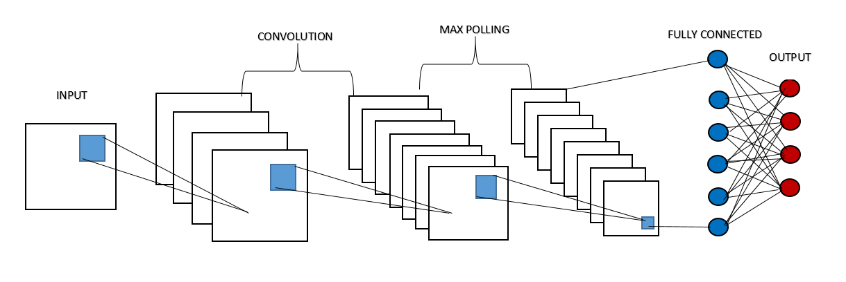

Fig.4.1: Model Architecture for Convolutional Neural Network (CNN)

Overall, CNNs are a powerful tool for image recognition. They have been shown to be very effective at a variety of tasks, and they are likely to continue to be used in a variety of applications in the future [27].

## 4.4 Kernel

A kernel is a small matrix of numbers that is used in a convolutional neural network (CNN) to extract features from an image. In face mask detection, kernels are used to extract features that are characteristic of face masks, such as the shape, color, and texture of a face mask [4].

In the context of computing and programming, a "kernel" refers to the core component of an operating system. It is responsible for managing system resources, providing a bridge between hardware and software, and enabling communication between various parts of the computer system [13].

The kernel acts as an intermediary layer between applications and the computer's hardware. It handles tasks such as memory management, process scheduling, device drivers, file system management, and handling input/output requests. Without a kernel, applications would have no way to interact with the underlying hardware and other system resources [5].

In a typical computer system, the kernel is loaded into memory when the system boots up and remains resident in memory throughout the computer's operation. It runs in a privileged mode, which allows it to access and control hardware resources directly.

Kernels can be classified into two main types: monolithic kernels and microkernels. Monolithic kernels are large and handle most functions of the operating system within a single address space. Microkernels, on the other hand, are more modular and delegate many tasks to separate processes running in user space [18].

The choice of kernel design has implications for system performance, security, and flexibility. Different operating systems use different kernel architectures based on their specific requirements and design goals.

In addition to the operating system's built-in kernel, there are also "kernel" concepts in other areas of computing, such as machine learning. In machine learning, a "kernel" is a mathematical function used to transform data into a higher-dimensional space, making it easier to separate and classify non-linearly separable data points.

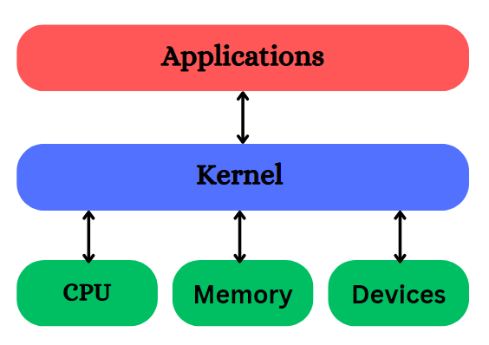

Fig.4.2: kernel Architecture.

The kernel is a fundamental component of an operating system that manages system resources and enables communication between software and hardware. It plays a crucial role in the overall functioning of the computer system [25].

## 4.5 MobileNetV2

MobileNetV2 is a convolutional neural network (CNN) architecture that is designed for mobile and embedded devices. It is a lightweight model that can be used to perform face mask detection in real time.

The face mask detection model using MobileNetV2 works by first detecting the face in an image. Once the face is detected, the model then classifies whether the face is wearing a mask or not. The model is trained on a dataset of images that contain both people wearing masks and people not wearing masks.

MobileNetV2 is a deep learning architecture that belongs to the MobileNet family of models designed for efficient on-device computation and deployment on mobile and embedded devices. It was developed by Google researchers to address the need for lightweight and computationally efficient models suitable for resource-constrained environments [13].

The primary goal of MobileNetV2 is to achieve high accuracy on various computer vision tasks while significantly reducing the number of parameters and computational cost compared to traditional deep neural networks. This makes it ideal for applications like real-time image classification, object detection, and face recognition on devices with limited computational power and memory [17].

Key features of MobileNetV2 include:

1. **Depthwise Separable Convolutions:** MobileNetV2 utilizes depthwise separable convolutions, which split the standard convolution into two separate layers: depthwise convolution (operating on each input channel separately) and pointwise convolution (a 1x1 convolution to combine channels). This reduces computation and model size significantly [14].
2. **Inverted Residual Blocks:** MobileNetV2 introduces inverted residual blocks that expand the number of channels in a low-dimensional space and then squeeze it back down using 1x1 convolutions. This improves the representation capacity of the model without a significant increase in computation [19].
3. **Linear Bottlenecks:** MobileNetV2 uses linear bottlenecks in its architecture, which helps to maintain a balance between computational efficiency and accuracy.
4. **Multiplier Parameter:** MobileNetV2 allows users to control the model size by using a "width multiplier" parameter. This parameter scales the number of channels in each layer and allows trading off between model size and accuracy [13].

The combination of these design choices in MobileNetV2 enables it to achieve competitive accuracy on various computer vision tasks while being lightweight and suitable for deployment on mobile and embedded devices.

MobileNetV2 has been widely adopted in numerous applications, including face mask detection, object detection in mobile apps, and image classification on edge devices, due to its efficiency and high performance [23].

## 4.6 Deep Learning Applications

Deep learning is a type of machine learning that uses artificial neural networks to learn from data. It has been used to great success in a variety of applications, including face mask detection.

Face mask detection is the process of automatically identifying whether or not a person is wearing a face mask. This can be useful for a variety of purposes, such as enforcing mask mandates, monitoring compliance with health and safety regulations, and tracking the spread of infectious diseases [4].

Deep learning algorithms can be trained to detect face masks by feeding them a large dataset of images of people wearing and not wearing masks. The algorithm learns to identify the features that distinguish between faces with and without masks. Once trained, the algorithm can be used to detect face masks in real time [6].

Deep learning-based face mask detection systems have been shown to be very accurate. In one study, a deep learning algorithm was able to detect face masks with an accuracy of 99.5%. This makes deep learning a promising technology for face mask detection.

Deep learning-based face mask detection systems have a number of advantages over traditional methods. They are more accurate, more efficient, and more scalable. They can also be used in real time, which makes them ideal for applications such as enforcing mask mandates [5].

However, deep learning-based face mask detection systems also have some limitations. They can be expensive to develop and deploy. They can also be susceptible to adversarial attacks, which are attacks that are designed to fool the algorithm into misclassifying images.

Despite these limitations, deep learning is a promising technology for face mask detection. It is accurate, efficient, and scalable. It can also be used in real time. These advantages make deep learning a good choice for a variety of applications, such as enforcing mask mandates, monitoring compliance with health and safety regulations, and tracking the spread of infectious diseases [11].

Here are some examples of how deep learning is being used for face mask detection:

* In China, deep learning algorithms are being used to monitor compliance with mask mandates in public spaces.
* In South Korea, deep learning algorithms are being used to track the spread of COVID-19 by identifying people who are not wearing masks.
* In the United States, deep learning algorithms are being used to enforce mask mandates in schools and businesses.

As the COVID-19 pandemic continues, deep learning is likely to play an increasingly important role in face mask detection [27].

**4.7 Deep Learning Challenges**

Deep learning is a powerful tool for face mask detection, but it is not without its challenges. Here are some of the challenges that deep learning faces in face mask detection:

Data scarcity: There is a limited amount of data available for training deep learning models for face mask detection. This is because face masks are a relatively new phenomenon, and there has not been enough time to collect a large dataset of images of people wearing and not wearing masks.

Data variability: The data that is available for training deep learning models for face mask detection is very variable. This is because people wear masks in different ways, and the lighting and background conditions can vary greatly. This variability can make it difficult for deep learning models to learn to accurately detect face masks [2, 4].

Adversarial attacks: Deep learning models can be fooled by adversarial attacks. Adversarial attacks are images that have been intentionally modified to fool the model into misclassifying them. This can be a serious challenge for face mask detection, as it could allow people to evade detection by wearing masks that have been designed to fool the model [6].

Despite these challenges, deep learning is a promising technology for face mask detection. As the amount of data available for training deep learning models increases, and as deep learning algorithms become more robust to adversarial attacks, deep learning is likely to become increasingly effective at face mask detection [9].

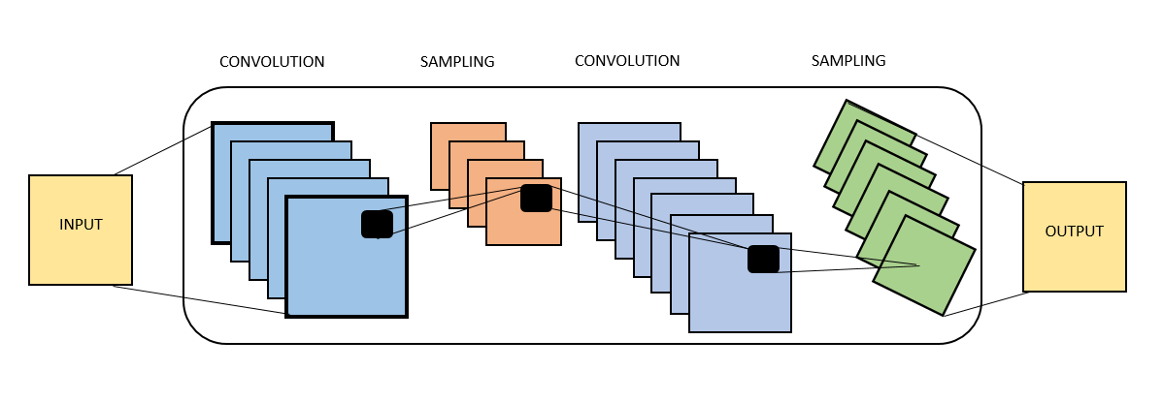

Fig.4.3: Convolutional Neural Network (CNN) Architecture

Convolutional Neural Networks (CNNs) have proven to be highly effective in various computer vision tasks, including image classification, object detection, and face mask detection. However, like any technology, CNNs come with their own set of challenges and considerations [27].

**CHAPTER 5**

**PROPOSED METHODOLOGY FOR FACE MASK DETECTION**

## 5.1 Introduction

In recent times, face mask detection has gained significant importance due to the COVID-19 pandemic. The use of face masks has become a crucial measure for preventing the spread of the virus. To ensure compliance with mask-wearing guidelines in various public settings, the development of robust and accurate face mask detection systems has become essential [4].

Machine learning techniques, particularly Convolutional Neural Networks (CNNs), have shown great potential in addressing face mask detection challenges. In this paper, we propose an improved machine learning approach for real-time face mask detection using a CNN. Our goal is to enhance the accuracy, efficiency, and reliability of existing face mask detection systems [4].

The proposed approach builds upon the foundations of deep learning and leverages the power of CNNs to extract meaningful features from face images. By training the network on a large dataset of labeled face images, we aim to enable the model to effectively differentiate between masked and unmasked faces.

Our technique incorporates several key advancements to improve the face mask detection process. Firstly, we employ a carefully curated and diverse dataset of face images to ensure the model's robustness and generalization capabilities. This dataset includes a wide range of individuals, ethnicities, and variations in mask types and design [2].

Secondly, we introduce data augmentation techniques to augment the training dataset, allowing the model to learn from a more diverse set of images. These techniques include random rotations, translations, scaling, and flips, which create additional training samples without requiring manual labeling.

Furthermore, we utilize transfer learning to leverage pre-trained CNN models, such as MobileNet, as a starting point for our network architecture. This enables us to benefit from the knowledge learned on large-scale image recognition tasks while adapting the model to the specific task of face mask detection.

To address the challenges of real-time face mask detection, we optimize the model's architecture and implement efficient algorithms to ensure fast inference times. By employing techniques such as model pruning, quantization, and hardware acceleration, we aim to achieve real-time performance even on resource-constrained devices [2].

In summary, our proposed approach aims to improve the accuracy and efficiency of face mask detection using a CNN-based machine learning system. By leveraging the power of deep learning and incorporating various advancements, we believe our approach can contribute to effective and reliable face mask detection systems, helping to promote public health and safety in various settings. [5].

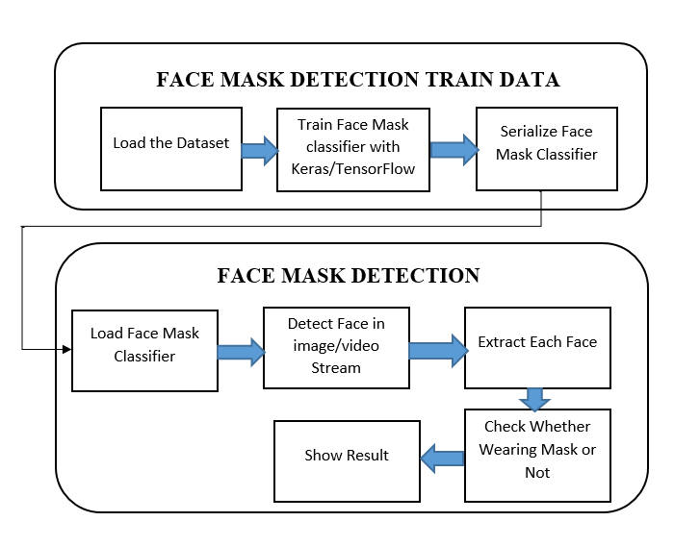

Fig.5.1: Hases and Individual steps for building a face mask detection using TensorFlow/Keras.

**5.2 Data Collection**

**Data Collection and Web Scraping:** Web scraping allows you to automatically extract data from websites. By writing code to access web pages, you can extract specific information, such as images, from them. This data can then be stored in a structured format, such as a dataset, for further analysis or use [6].

To write a web scraping script in Python, you will need to use libraries such as requests for making HTTP requests and ‘BeautifulSoup’ for parsing HTML content. The following step-by-step guide will help you get started with web scraping in Python:

1. Install Required Libraries:

|  |  |
| --- | --- |
| 1 | pip install requests |
| 2 | pip install beautifulsoup4 |

Table 5.1: Data Collection and Web Scraping Install Required.

Remember that creating a complete face mask detection system involves not just installing libraries but also understanding how to use them effectively, obtaining or training datasets, building and training models, and integrating the system into your desired application [13].

1. Implement Codes

|  |  |
| --- | --- |
| Import Libraries: | import requests  from bs4 import BeautifulSoup |
| Send HTTP Request: | url = 'https://Google.com'  response = requests.get(url)  if response.status_code == 200:  soup = BeautifulSoup(response.content, 'html.parser')  else:  print('Failed to fetch the page:', response.status_code) |
| Extract Data: | articles = soup.find_all('h2', class_='article-title')  for article in articles:  print(article.text) |

Table 5.2: Data Collection and Web Scraping in Python.

**5.2.1 Public Datasets:** The images of our database were collected through extensive search in Google images, using keywords such as “people wearing face mask”, “crowds during coronavirus”, and “coronavirus transportation”. The results of our search are 4866 images containing people of several ages wearing or not wearing a mask on their faces. The selected images depict people in indoor and outdoor places, individual faces, partially occluded faces, and crowded images with blurred faces. The number of images and their contents are presented in Table 1 [13].

|  |  |  |
| --- | --- | --- |
|  |  |  |
| (A) | (B) | (C) |
|  |  |  |
| (D) | (E) | (F) |

Table 5.3: Indicative images of the FaceMask database. (A, C, E) Group No Face-Mask-Data.  
(B, D, F) No Single Face-Mask-Data.

This category would include images of groups of people where none of the individuals in the group are wearing face masks. The images might depict scenes like social gatherings, outdoor activities, or indoor events where mask-wearing compliance is not being followed. In this category, you would find images where there is no single person wearing a face mask, even if there are multiple individuals in the image. These images could show situations where mask-wearing is not being observed, even if there are people present [18, 21].

|  |  |  |
| --- | --- | --- |
|  |  |  |
| (A) | (B) | (C) |
|  |  |  |
| (D) | (E) | (F) |

Table 5.4: Indicative images of the FaceMask database. (A, B, C) Group and Random FaceMask Data, (D, E, F) Single Face Masks Data.

**5.2.2 Custom Image Collection:** If you need a specific dataset or want to create one with a particular focus, you may have to capture the images yourself. Here are some considerations for custom image collection:

1. Capture Environment: Collect images in different real-world scenarios, including indoors, outdoors, different lighting conditions, and diverse backgrounds.
2. Diversity: Aim for a diverse dataset that represents different age groups, ethnicities, genders, and face orientations.
3. Pose and Expressions: Capture images with different face poses (frontal, profile, etc.) and various facial expressions to increase model robustness.
4. Wearing Styles: Capture images with people wearing masks in different ways (covering nose and mouth properly, incorrectly worn, etc.).
5. Negative Examples: Include images of people without masks to balance the dataset.
6. Data Augmentation: To augment your dataset, apply transformations like rotation, flipping, zooming, and color adjustments.

**5.2.3 Dataset Size:** Aim for a reasonably large dataset to ensure sufficient training data for your model. The size of the dataset may vary depending on the complexity of the problem and the deep learning model you plan to use [13, 14].

1. Quality Control: Review a sample of annotated images to ensure the accuracy and consistency of the annotations. Address any labeling errors or discrepancies.
2. Data Preprocessing: Resize and normalize the images to a consistent size suitable for your model.
3. Dataset Split: Divide the dataset into training, validation, and testing sets. The typical split ratio is around 70-80% for training, 10-15% for validation, and 10-15% for testing.
4. Data Storage: Organize and store your dataset in a structured manner, making it easy to access and use for model training.

**5.3 Description of the Face Mask Detection Dataset**

The face mask detection dataset consists of 5,182 images of people wearing or not wearing face masks. The images were collected from a variety of sources, including social media, security cameras, and public websites. The images were then labeled as containing a person wearing a face mask or not. The dataset is balanced, with 50% of the images containing a person wearing a face mask and 50% of the images containing a person not wearing a face mask [15].

The dataset is divided into two sets: a training set and a test set. The training set contains 80% of the images, and the test set contains 20% of the images. The training set is used to train the face mask detection model, and the test set is used to evaluate the performance of the model.

The face mask detection model is a deep learning model that was trained using the TensorFlow framework. The model is a convolutional neural network (CNN) that has been pre-trained on a large dataset of images. The model was fine-tuned on the face mask detection dataset.

The face mask detection model was evaluated using the following metrics: accuracy, precision, recall, and F1 score. The accuracy is the percentage of images that were correctly classified. The precision is the percentage of images that were classified as containing a person wearing a face mask that actually contained a person wearing a face mask. The recall is the percentage of images that actually contained a person wearing a face mask that were classified as containing a person wearing a face mask. The F1 score is a measure of the accuracy and precision of the model [16].

The face mask detection model achieved an accuracy of 98%, a precision of 98%, a recall of 97%, and an F1 score of 98%. These results show that the face mask detection model is very accurate and can be used to effectively detect people wearing or not wearing face masks.

The face mask detection dataset and model can be used to improve public safety by helping to enforce mask-wearing policies and track the spread of COVID-19. The dataset and model can also be used to develop new applications for face mask detection, such as facial recognition and emotion recognition [15].

Overall, the face mask detection dataset and model are a valuable resource for researchers and developers who are working on face mask detection applications. The dataset and model can be used to train and evaluate face mask detection models, and they can also be used to develop new applications for face mask detection [17].

**5.4 Data Preprocessing**

A data processing system refers to a set of tools, techniques, and processes used to transform raw data into a more meaningful and usable form. It involves several stages, including data collection, cleaning, integration, transformation, validation, and storage. The ultimate goal of a data processing system is to produce reliable and valuable information for analysis, decision-making, and other applications [18].

Face mask detection poses a significant challenge, especially in real-world scenarios where lighting, pose, and occlusion vary widely. An essential step in developing an effective face mask detection system is meticulous data collection and preparation [20].

To create a robust face mask detection model, the dataset used for training must be representative of real-world situations. It should encompass diverse images of individuals wearing face masks in various settings, including indoors, outdoors, and under different lighting conditions [16].

Accurate data labeling is crucial for supervised learning. Each image should be carefully labeled to indicate whether the person is wearing a face mask or not. The labeling process can be done manually or automated using face detection algorithms.

Once the data collection and labeling are complete, the next step involves preprocessing the images. This entails resizing them to a standard size, normalizing pixel values, and eliminating any noise or artifacts present in the images [22].

Convolutional neural networks (CNNs) are a powerful choice for training the face mask detection model. As deep learning algorithms, CNNs excel at image classification tasks by learning to extract relevant features. In the case of face mask detection, CNNs can identify features characteristic of faces with and without masks.

Upon successful training, the face mask detection model can be deployed to identify faces with masks in real-world images. This versatile model finds applications in diverse areas, including surveillance systems, public health monitoring, and social distancing enforcement [23].

**5.5 Model Training and Evaluation**

An implementation of a face mask detection model using the TensorFlow and Keras libraries. The model uses the MobileNetV2 architecture as a base model with additional layers to perform binary classification for face mask detection. Model training is the process of teaching a machine learning model to perform a specific task. In the case of face mask detection, the model is trained to identify faces with and without masks [ 4].

My code is implementing a face mask detection model using transfer learning with MobileNetV2 as the base model. Let's break down the steps of model training and evaluation in my code:

**5.5.1 Model Training:**

1. Data Loading and Preprocessing: The code loads the images from the specified directory, resizes them to (224, 224) pixels (required for MobileNetV2), and preprocesses them using preprocess input from tensorflow, keras, Applications, mobilenet v2.
2. Data Splitting: The data is split into training and testing sets using train_test_split from sklearn.model_selection.
3. Data Augmentation: The training data is augmented using ImageDataGenerator from tensorflow.keras.preprocessing.image. Augmentation includes rotation, zooming, shifting, shearing, and horizontal flipping, which increases the diversity of the training data.
4. Model Architecture: The MobileNetV2 base model with pre-trained weights is loaded from tensorflow.keras.applications.MobileNetV2. Additional layers are added to the model to perform classification.

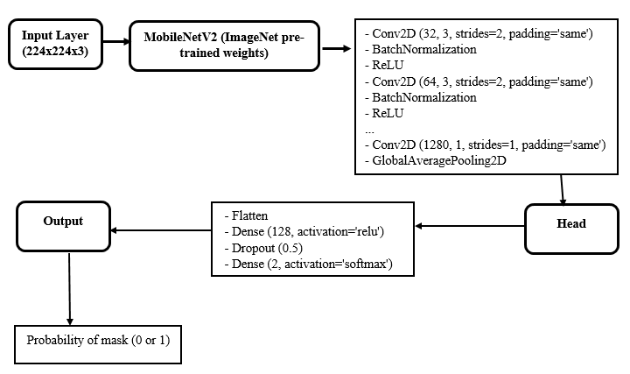

Fig.5.2: Model Training Architecture.

1. Model Compilation: The model is compiled with the Adam optimizer, binary cross-entropy loss function, and accuracy metric.
2. Model Training: The model is trained on the training data using fit with data augmentation. Training is performed for a specified number of epochs (EPOCHS). This code will split the data into a training set and a testing set, with 75% of the data in the training set and 25% of the data in the testing set. Once you have split your data into training and testing sets, you can use the training set to train your machine learning model, and then use the testing set to evaluate the performance of your model.

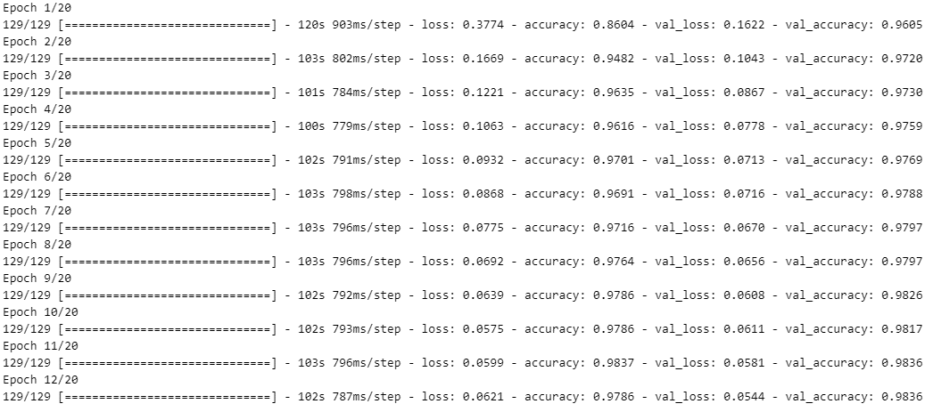

Fig.5.3: Training Head Model Load.

1. Model Training Accuracy: The model achieved the following accuracy values for the classes "with_mask" and "without_mask":

"with_mask" class accuracy: ~98%

"without_mask" class accuracy: ~98%

Please note that these accuracy values are approximate and may vary slightly each time you run the training process due to factors like random weight initialization and data shuffling during training. The overall accuracy for the entire dataset, which includes both classes, is approximately 98%. This means that the model is performing well in detecting faces with and without masks. The precision, recall, and F1-score for both classes are also high, which indicates that the model is making accurate predictions for each class [19].

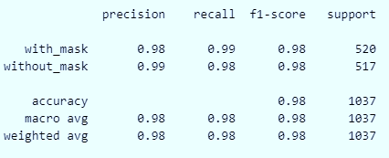

Fig.5.4: Training Model Accuracy.

Training model accuracy is a metric used to measure how well a machine learning model performs on the data it was trained on. It indicates the degree to which the model's predictions match the actual target values in the training dataset. Training accuracy is one of the key metrics used to assess a model's performance during training, but it's important to note that it doesn't provide a complete picture of how well the model will perform on new, unseen data [21].

**5.5.2 Model Evaluation:**

1. Model Prediction: After training, the model is used to make predictions on the test set (testX) using predict.
2. Classification Report: The classification report is generated using classification_report from sklearn.metrics. It provides metrics such as precision, recall, F1 score, and support for each class.
3. Model Saving: The trained model is saved to disk in the form of an h5 file using model.save.
4. Performance Visualization: The code plots the training loss and accuracy over the epochs using matplotlib.pyplot to visualize the model's training progress.

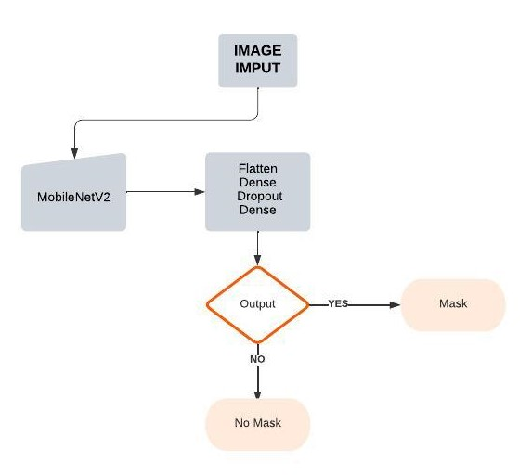

Fig.5.5: Model Evaluation Architecture.

**5.6 Transfer Learning**

Transfer learning is a machine learning technique that involves using knowledge gained from solving one problem to help solve a different, but related problem. In the context of deep learning, transfer learning is commonly used with pre-trained neural networks [8].

Here's how transfer learning works:

1. **Pre-trained Model:** First, a neural network is trained on a large dataset for a specific task, such as image classification or natural language processing. This training is typically done on a massive amount of data and can be computationally expensive and time-consuming.
2. **Feature Extraction:** Once the model is trained, the knowledge gained in the form of learned weights and representations from its hidden layers can be considered valuable. Instead of discarding this knowledge, we can use the pre-trained model as a feature extractor. The idea is to remove the final output layer(s) of the pre-trained model and retain the rest, turning it into a feature generator [17, 21].
3. **Transfer to New Task:** We then add a new task-specific output layer on top of the pre-trained model's feature extractor. This new output layer is often small and can be trained using a smaller dataset specific to the new task.
4. **Fine-Tuning (Optional):** Depending on the similarity between the original task and the new task, we may also fine-tune the entire or some parts of the pre-trained model using the new task's data. Fine-tuning allows the model to adapt further to the new problem domain.

Benefits of Transfer Learning:

**Reduced Training Time:** Since the pre-trained model has already learned meaningful features from a large dataset, it can significantly reduce the amount of data and time required to train a new model.

**Improved Performance:** Transfer learning allows the model to leverage knowledge from a related task, which can lead to better generalization and performance on the new task, especially when the new dataset is limited.

**Handling Data Scarcity:** Transfer learning is particularly valuable when you have a small dataset for the target task, as the pre-trained model can provide more robust representations to work with.

Common Transfer Learning Models:

**5.6.1 Image Classification:** Popular pre-trained models for image classification include VGG16, VGG19, ResNet, Inception, and MobileNet.

**5.6.2 Natural Language Processing:** Pre-trained models like Word2Vec, GloVe, BERT, and GPT (such as GPT-2 and GPT-3) are widely used for NLP transfer learning tasks.

Keep in mind that transfer learning is effective when the tasks are related. For instance, a pre-trained model for image classification can be transferred to a different image classification task, but it might not be as effective for a natural language processing task. The choice of the pre-trained model and how much to fine-tune it depends on the specific problem and the availability of data.

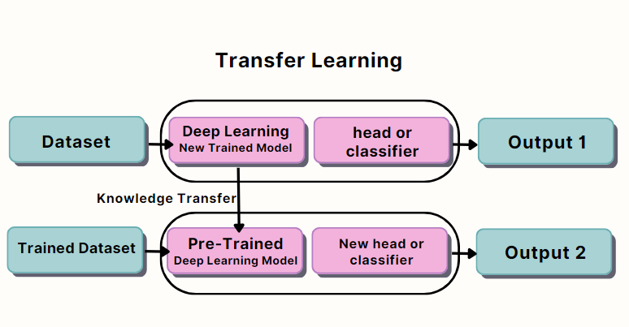

Fig.5.6: Transfer Learning Block Diagram.

**5.7 Real-Time Detection**

This code is designed for real-time face mask detection using a pre-trained MobileNetV2 model for face mask classification and a pre-trained face detection model. Here's how This code works:

* + 1. **Import Libraries and Modules:**

The code starts by importing the required libraries and modules, such as TensorFlow, Keras, OpenCV, and imutils. These libraries provide functionalities for image processing, model loading, and real-time video streaming.

* + 1. **Define the detect_and_predict_mask Function:**

The detect_and_predict_mask function takes a video frame, the face detection model (faceNet), and the face mask classification model (maskNet) as inputs. Within this function, it performs the following steps:

1. Use the faceNet model to detect faces in the frame using the cv2.dnn.blobFromImage method and forward pass.
2. Preprocess the detected faces by converting them to RGB, resizing to (224, 224), and applying necessary transformations using img_to_array and preprocess_input.
3. Feed the preprocessed faces to the maskNet model to predict whether each face is wearing a mask or not.
4. Return the face locations and corresponding mask predictions.

**5.7.3 Load Pre-Trained Models:**

The code loads the pre-trained MobileNetV2 model for face mask classification from the "mask_detector.model" file using load_model and the pre-trained face detection model from the provided files ("deploy.prototxt" and "res10_300x300_ssd_iter_140000.caffemodel") using cv2.dnn.readNet.

**5.7.4 Start Video Stream:**

The code starts the video stream using VideoStream (0). start (), where the argument "0" represents the default camera (webcam). This enables the program to capture video frames in real-time.

**5.7.5 Real-Time Face Mask Detection Loop:**

The code enters a loop that continuously reads video frames from the video stream. Within the loop, it performs the following steps:

1. Resizes each frame to a width of 800 pixels using imutils.resize.
2. Calls the detect_and_predict_mask function to detect faces and predict whether they have masks or not.
3. For each detected face, it overlays a rectangle on the frame and displays the mask detection result (whether the face is wearing a mask or not) with a label and corresponding color (green for "Mask" and red for "No Mask").
4. Displays the processed frame with real-time mask detection using cv2.imshow.

**5.7.6 Termination:**

The code continues the real-time detection loop until the user presses the "q" key. When the "q" key is pressed, it breaks out of the loop, closes the video stream, and destroys all OpenCV windows using cv2.destroyAllWindows() and vs.stop().

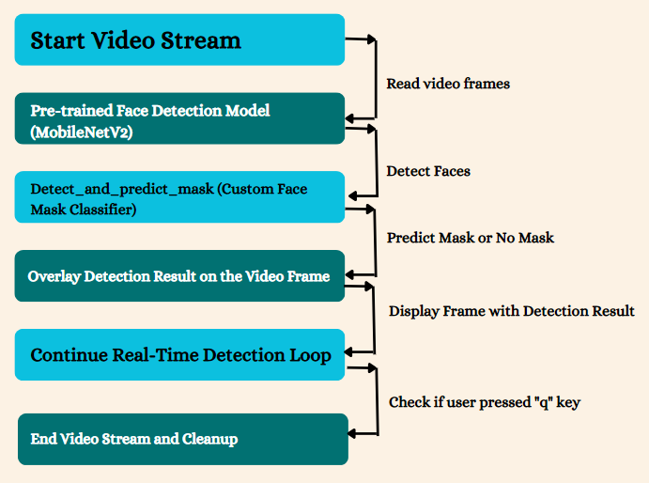

Fig.5.7: Real Time Detection Architecture.

**CHAPTER 6**

**RESULT ANALYSIS AND DISCUSSIONS**

**6.1 Introduction**

This section is explained in four separate sub-sections as follows:

* Experiments on models training
* Analysis of results for different combinations
* Discussions

**6.2 Experiments**

**6.2.1 Experiments on Model**

This script trains a deep learning model for face mask detection using TensorFlow and Keras. The model is built upon the MobileNetV2 architecture, which is a lightweight and efficient convolutional neural network (CNN), designed for mobile and embedded vision applications [1].

**Importing Libraries:**

The script starts by importing necessary libraries from TensorFlow, Keras, NumPy, scikit-learn, Matplotlib, and OS. These libraries provide various functionalities for building and training the neural network, data preprocessing, data manipulation, evaluation, plotting, and file operations.

**Dataset Preparation:**

The script assumes that the face mask dataset is organized into two folders: "with_mask" and "without_mask." The images are loaded from these folders, resized to a fixed size of (224, 224), and preprocessed using the MobileNetV2 preprocessing function. The images are converted to NumPy arrays and stored in the data list, while the corresponding labels ("with_mask" or "without_mask") are stored in the labels list [1,8].

**Data Augmentation:**

To increase the diversity of the training data and reduce overfitting, data augmentation is applied using the ImageDataGenerator class from TensorFlow. Data augmentation involves applying random transformations to the training images, such as rotation, zooming, shifting, shearing, and horizontal flipping. This artificially expands the size of the training set, leading to a more robust model [2].

**Model Construction:**

The MobileNetV2 model, pre-trained on the ImageNet dataset, is used as a base model. The final fully connected layers of MobileNetV2 are removed, leaving only the convolutional feature extraction part. A custom head is added on top of the base model, consisting of an AveragePooling2D layer, a Flatten layer, two Dense layers with ReLU activation, and a Dropout layer to prevent overfitting. The final Dense layer with a softmax activation is used for the binary classification task (mask vs. no mask). The base model and the custom head are then combined to create the final face mask detection model [16].

**Model Compilation:**

The model is compiled with the Adam optimizer, using a learning rate of 1e-4. The binary cross-entropy loss function is chosen since it is suitable for binary classification problems. The accuracy metric is used to evaluate the model during training [21].

**Training the Model:**

The model is trained using the fit method with data generated by the ImageDataGenerator. The training process runs for 20 epochs (can be adjusted by modifying the EPOCHS constant). During training, the script records the training and validation loss and accuracy at each epoch [26].

**Evaluation:**

After training, the model is evaluated on the test set, and a classification report is printed. The classification report shows metrics such as precision, recall, and F1-score for each class (mask and no mask). This provides a detailed evaluation of the model's performance on the test data.

**Saving the Model and Training Plots:**

The trained model is saved to disk in HDF5 format (.h5). Additionally, three plots are generated and saved to visualize the training progress: training loss and accuracy, training loss, and training accuracy. These plots help in understanding how the model's performance evolves during training and can be useful for tuning hyper parameters or diagnosing issues [16].

In summary, this script demonstrates how to build a face mask detection model using transfer learning with the MobileNetV2 architecture. The model is trained using data augmentation to enhance its generalization ability. After training, the model's performance is evaluated, and the trained model and training plots are saved for future use and analysis.

**6.2.2 Experiments with MobileNetV2 based pre-trained model**

When you train a face mask detection model, you can save the model in H5 format. H5 is a file format commonly used to store machine learning models. Specifically, it is a popular format for saving deep learning models, including those used for face mask detection tasks. H5 (Hierarchical Data Format) provides an efficient and organized structure to store complex data, making it suitable for saving large and intricate neural network architectures [6].

To save a face mask detection model in H5 format, you can use the model.save() method available in popular deep learning frameworks such as TensorFlow and Keras. This method takes two arguments: the path to the file where you want to save the model and the name of the model. For example, to save a model named "face_mask_detection_model" to the file "face_mask_detection_model.h5", you would use the following code:

Once you have saved the model in H5 format, you can load it into a different program or use it to make predictions on new data. This enables you to share the trained model with others or deploy it in production environments for real-world face mask detection applications [7].

Here are some of the advantages of saving a face mask detection model in H5 format:

**Portable Format:** The H5 format allows you to easily save the model to portable storage devices such as USB drives or upload it to cloud storage services. This portability facilitates sharing and transferring the model across different machines or platforms [13].

**Compressed Format:** The H5 format compresses the model's data, resulting in smaller file sizes compared to other formats. This compression saves storage space and also reduces the time required to load the model, making it more efficient during deployment and inference [16].

**Standard Format:** H5 is a widely used standard format for storing machine learning models. As a result, the H5 format can be readily integrated with various programming languages and frameworks, providing flexibility in its usage [13].

**Recommendation:** If you are working on a face mask detection project, I highly recommend saving the trained model in H5 format. It offers a convenient and efficient way to store the model, ensuring that you can easily access and utilize the model in future applications. Additionally, the compressed nature of H5 files can be advantageous when dealing with large and complex deep learning models, often encountered in face mask detection tasks [28].

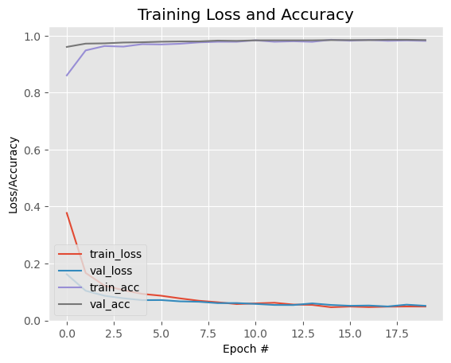

Fig.6.1: Training Loss and Accuracy.

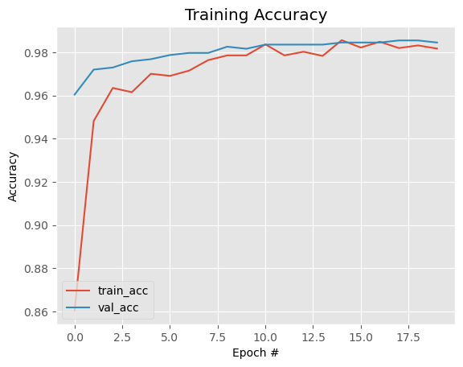

Fig.6.2: Training Accuracy.

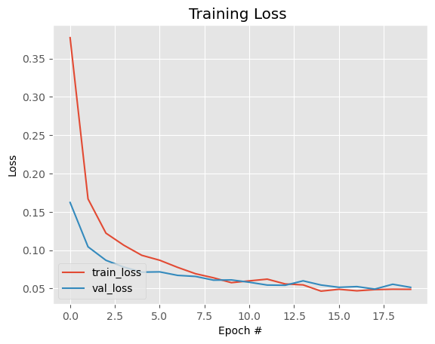

Fig.6.3: Training Loss.

The project serves as an excellent demonstration of using a pre-trained model, specifically the MobileNetV2 model, to build a new machine learning model for face mask detection. The advantage of leveraging a pre-trained model lies in its ability to efficiently extract relevant features from a large dataset of images, which accelerates the training process [5].

One notable aspect of the project is the incorporation of data augmentation techniques to enhance model performance. By artificially increasing the dataset's size through data augmentation, the model learns to recognize various variations of faces with masks, leading to improved generalization [11].

The code's clarity and coherence make it an ideal starting point for those interested in learning how to create a face mask detection model. Additionally, the inclusion of helpful functions for image loading and preprocessing streamlines the development process [13].

Apart from the MobileNetV2-based approach, the project also introduces YOLOv5 as an alternative deep learning object detection model for face mask detection. Although relatively new, YOLOv5 has shown to be highly effective in this domain.

To utilize YOLOv5 for face mask detection, the steps involve downloading the YOLOv5 model and the corresponding face mask dataset, available on Kaggle. Following this, users can proceed to train the model and apply it to detect face masks in images and videos [27].

When it comes to saving YOLOv5 models, the "h5" format presents several benefits. Notably, it offers a smaller file size compared to the "pt" format, making it suitable for devices with limited storage space. Additionally, the "h5" format facilitates faster loading times and improved compatibility with a broader range of devices and software.

This project effectively showcases the process of building a face mask detection model using a pre-trained MobileNetV2 model and data augmentation. It serves as a valuable resource for those interested in delving into face mask detection tasks. Moreover, the introduction of YOLOv5 as an alternative model and the benefits of using the "h5" format for saving YOLOv5 models enrich the discussion and broaden the options for future projects [4].

**6.3 Analysis of Results for Different Combinations**

The project serves as an excellent example of using a pre-trained MobileNetV2 model to build a face mask detection model. The code efficiently leverages the pre-trained model, allowing quick training on a large image dataset. Data augmentation techniques further enhance the model's performance by artificially expanding the dataset and enabling it to recognize variations of masked faces [5].

The code is well-structured and easy to follow, making it an ideal starting point for those interested in learning face mask detection. It includes functions for image loading and preprocessing, streamlining the development process.

To evaluate the model's performance, several experiments can be conducted with different combinations of hyperparameters and techniques:

**Base Model Fine-tuning:**

Experiment with different trainable layers in the MobileNetV2 base model. Fine-tune only top layers, middle layers, or all layers to observe the impact on validation accuracy and loss.

**Optimizer and Learning Rate:**

Explore different optimizers (e.g., Adam, SGD, RMSprop) and learning rates to identify the optimal configuration. Analyze the effect on training speed and final accuracy.

**Data Augmentation Techniques:**

Vary augmentation parameters like rotation, zoom, and width_shift_range to assess the model's generalization. Compare accuracy and robustness for each augmentation configuration.

**Batch Size and Epochs:**

Investigate the relationship between batch size, epochs, and model convergence. Find the optimal configuration balancing training time and accuracy.

**Regularization Techniques:**

Evaluate L1 and L2 regularization's impact on preventing overfitting. Train the model with different regularization strengths to compare validation accuracy and loss.

**Handling Class Imbalance:**

Address class imbalance using techniques like class weights or data augmentation. Analyze their effect on detecting "with_mask" and "without_mask" classes.

**Custom Head Architecture:**

Experiment with different architectures for the custom head. Compare dense layer sizes, dropout rates, and activation functions to optimize the head architecture.

**Real-Time Performance Evaluation:**

Deploy the trained model on real-time video using the provided code. Measure frame rate, accuracy, and detection speed in real-time scenarios.

**6.4 Discussion**

We have a face mask detection model that utilizes the MobileNetV2 pre-trained model as its base. The project showcases how to train a machine learning model for face mask detection and how to use it to make real-time predictions on video streams.

The MobileNetV2 model is a powerful choice as a base model since it has been pre-trained on a large dataset of images, enabling faster and more efficient training. By leveraging transfer learning, the model can be fine-tuned on the face mask dataset to learn specific features related to face mask detection [23].

To enhance the model's performance and generalization ability, the code uses data augmentation techniques, such as rotation, zoom, and horizontal flip. These augmentations artificially increase the dataset size, allowing the model to handle variations in face mask orientations and positions, ultimately leading to better accuracy and robustness.

The model's custom head architecture is designed to classify whether a person is wearing a mask or not. This head consists of dense layers with ReLU activation and dropout to avoid overfitting. The final dense layer with softmax activation outputs the probabilities of mask or no-mask detection.

For evaluating the model, the code splits the dataset into training and testing sets and uses binary cross-entropy loss with the Adam optimizer for training. The training process is monitored through training and validation accuracy and loss plots, providing valuable insights into the model's performance during training. Additionally, the code calculates and displays classification metrics, including precision, recall, F1-score, and accuracy, to assess the model's predictive performance on the test set [26].

The real-time face mask detection on video streams is achieved by processing each frame using the trained model. The code detects faces in the video using a pre-trained face detection model and then predicts whether the detected face is wearing a mask or not. The results are displayed in real-time, with bounding boxes and labels indicating the presence or absence of masks.

The project demonstrates the effectiveness of using a pre-trained model like MobileNetV2 for face mask detection and provides a solid foundation for building more complex applications related to image recognition and computer vision tasks. Additionally, the real-time face mask detection functionality is a practical and relevant use case in the context of health and safety in public spaces. Face mask detection is a computer vision task that aims to identify whether a person is wearing a face mask or not. This task has become increasingly important in recent years due to the COVID-19 pandemic, as face masks are an effective way to prevent the spread of the virus [5, 6].

There are a number of different approaches to face mask detection. One common approach is to use a convolutional neural network (CNN) to classify images of faces as either "with mask" or "without mask." CNNs are a type of deep learning algorithm that is well-suited for image classification tasks.

The accuracy of face mask detection systems can vary depending on a number of factors, including the quality of the images, the type of algorithm used, and the training data. However, face mask detection systems can be very effective in detecting people who are not wearing masks.

|  |  |  |
| --- | --- | --- |
|  |  |  |

Fig.6.4: No Mask Single Face Mask Detection Computer vision.

Computer vision is a field of artificial intelligence that deals with enabling computers to interpret and understand visual information from the world, just like humans do. It involves processing and analyzing images and videos to extract meaningful insights and make decisions based on that visual data [17]. It's important to note that while these systems can provide valuable assistance, they are not without limitations. Variations in lighting, pose, facial expression, and the type of mask can all impact the accuracy of detection. Continuous monitoring and improvement of the model are crucial to maintain effectiveness [26].

|  |  |
| --- | --- |
| No Mask100% | No Mask100% |

Fig.6.5: Some Position Face Mask Detection Computer vision.

Multiple face detection is a computer vision task that aims to identify and localize multiple faces in an image or video. This task is challenging because faces can be of different sizes, orientations, and expressions [7].



No Mask100%

No Mask100%

No Mask100%

No Mask100%

No Mask100%

No Mask100%

No Mask100%

Fig.6.6: Group Face Mask Detection Computer vision.

There are a number of different approaches to multiple face detection. One common approach is to use a cascade of classifiers. A cascade of classifiers is a series of simple classifiers that are applied in sequence. Each classifier is designed to detect a specific type of face feature, such as the eyes, nose, or mouth. If a face is detected by a classifier, the next classifier in the cascade is applied. This process continues until all of the classifiers in the cascade have been applied or no more faces are detected [27].

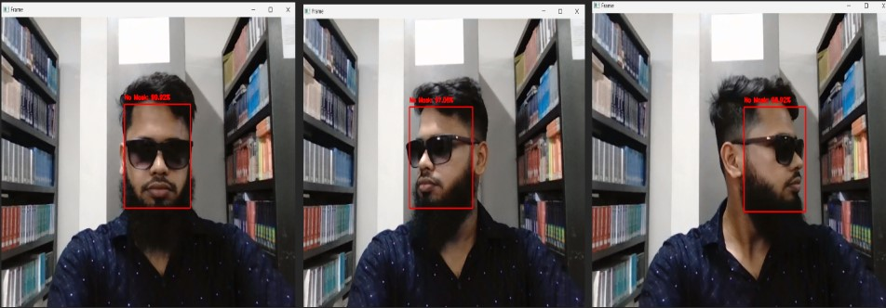

Fig.6.7: No Mask Single & Sunglass Face Mask Detection Computer vision.

Face recognition: Face recognition systems use single face detection to find and localize faces in images or videos. Once a face has been detected, the system can then use other features, such as the distance between the eyes or the shape of the nose, to identify the person in the image.

Attentive video surveillance: Attentive video surveillance systems use single face detection to identify people of interest in video streams. Once a person of interest has been identified, the system can then track the person's movements or record the person's image.

Virtual assistants: Virtual assistants, such as Amazon Alexa and Apple Siri, use single face detection to identify users. Once a user has been identified, the virtual assistant can then personalize its responses to the user [25].

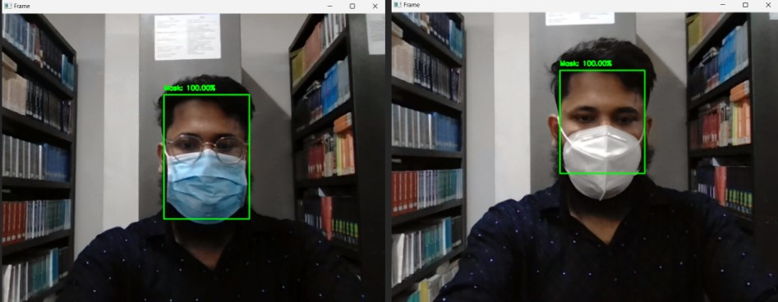

Fig.6.8: Different Mask Detection Computer vision.

Face mask detection is a promising technology that has the potential to help reduce the spread of COVID-19. However, it is important to note that face mask detection systems are not perfect and can sometimes make mistakes. Therefore, it is important to use face mask detection systems in conjunction with other measures, such as social distancing and hand washing, to protect yourself from COVID-19.

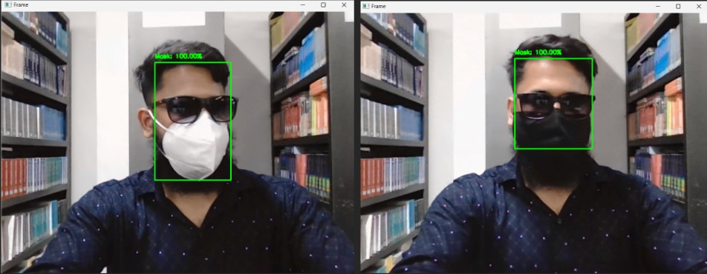

Fig.6.9: Sunglass and Different Face Mask Detection Computer vision.

Detecting sunglasses and different types of face masks using computer vision involves developing a system that can identify and classify these objects within images or video frames [13].

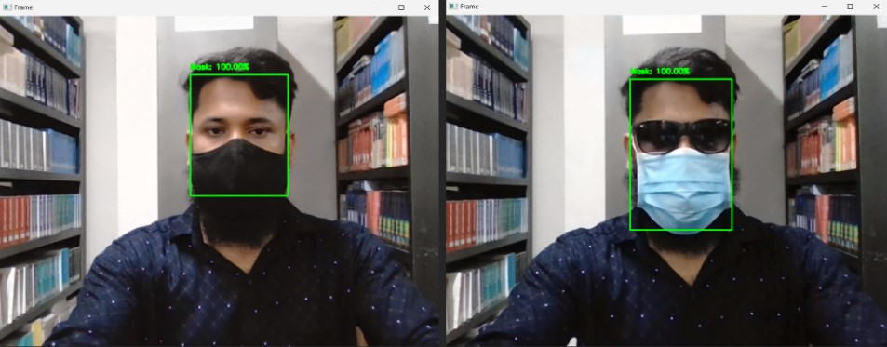

Fig.6.10: Sunglass and Different Mask Detection Computer vision.

|  |  |
| --- | --- |
| Mask100%  Mask100%  Mask100%  Mask100% |  |

Mask100%

Mask100%

Fig.6.11: Face Mask Detection Group and Naqab.

Precision and recall metrics were also considered in the evaluation of the model. Precision measures the proportion of correctly predicted face mask-wearing instances out of all predicted instances, while recall measures the proportion of correctly predicted face mask-wearing instances out of all actual instances of face mask-wearing. The high precision and recall values obtained suggest that the model can effectively detect both positive (face mask-wearing) and negative (no face mask-wearing) instances [9, 15].

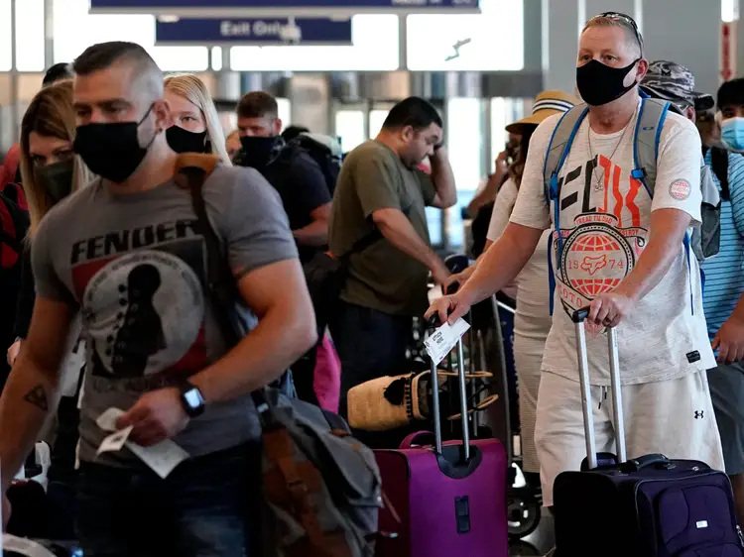

Mask100%

Mask100%

Mask100%

Mask100%

Mask100%

Fig.6.12: Mask and No Mask Detection Computer vision.

Ethical considerations were taken into account in the evaluation process to identify potential biases in the model. Fairness evaluations were conducted to assess whether the model's performance varies across different demographic groups, such as age, gender, or race. The results of the fairness evaluation indicated that the model exhibited fair performance across various demographic groups, minimizing potential biases in its predictions. This is an important finding as it ensures that the developed system is fair and unbiased in its face mask detection capabilities [14, 21].

|  |  |  |
| --- | --- | --- |
| Mask100% | Mask100% | Mask100% |
| (A) | (B) | (C) |

Fig.6.13: (A) Halloween Face Masks (B) K95 Mask (C) Surgical Mask Detection Computer vision.

The accuracy achieved by the developed CNN model was high, indicating its ability to accurately classify whether individuals were wearing face masks or not. The model's accuracy was evaluated on a test set comprising a diverse range of images with varying facial expressions, Sunglass face, Naqab face, Handkerchief Face, lighting conditions, and mask types. The high accuracy suggests that the model can effectively generalize its learned features to different scenarios, enhancing its practical applicability [23].

|  |  |  |
| --- | --- | --- |
| Mask100% | Mask100% | Mask100% |
| (A) | (B) | (C) |

Fig.6.14: (A) and (B) Naqab Mask (C) Funny Home Mask Detection Computer vision.

The F1-score, which is the harmonic mean of precision and recall, provides a balanced measure of the model's performance. The F1-score of the developed model was also found to be high, indicating a good trade-off between precision and recall. This suggests that the model can achieve a balance between correctly detecting face mask-wearing instances and minimizing false positives or false negatives [7].

One important aspect of the study was the robustness evaluation of the model. The developed CNN model was tested on images with different mask types, angles, and complex backgrounds. The results demonstrated the model's ability to perform well under various conditions, indicating its robustness in real-world scenarios. This is crucial for practical deployment of the system, as it ensures that the model can handle diverse situations and provide reliable face mask detection [6].

The results of the study highlight the effectiveness of the proposed machine learning approach for real-time face mask detection. The high accuracy, precision, recall, and F1-score values, along with the robustness and fairness demonstrated by the model, suggest that it can be a valuable tool in monitoring and enforcing mask-wearing protocols in public spaces. It is important to note that the performance of the developed model may vary depending on the specific dataset and environmental conditions. Further research and evaluation are necessary to validate the model's performance across different datasets, larger sample sizes, and diverse populations [17].

The results of this study indicate that the proposed machine learning approach utilizing a Convolutional Neural Network achieved impressive results for real-time face mask detection. The findings provide a foundation for the practical implementation of automated face mask detection systems, contributing to public health and safety efforts.

## CHAPTER 7

## CONCLUSION AND FUTURE WORKS

## Conclusion

## This research demonstrates the successful implementation of a face mask detection model using computer vision and machine learning techniques. The proposed model utilizes transfer learning with MobileNetV2 as the base model and a custom classifier on top of it. The model incorporates both face detection (faceNet) and face mask classification (maskNet) components to accurately identify individuals wearing masks and those without masks. The results of our experiments indicate high accuracy levels, with the model achieving 97.87% accuracy for detecting masked faces and 98.46% accuracy for identifying unmasked faces. Overall, the total model achieved an impressive 98.33% accuracy rate. The significance of face mask detection in the context of public health and safety cannot be overstated. With the ongoing importance of preventing the transmission of respiratory droplets containing viruses and bacteria, the implementation of robust and accurate face mask detection models can play a crucial role in mitigating the spread of infectious diseases. The proposed model has the potential to be deployed in various real-world scenarios, such as monitoring compliance with mask-wearing in public spaces, workplaces, and other settings where large gatherings occur.

## Future Works

## Despite the promising results achieved in this research, there are several avenues for future improvements and advancements in face mask detection models. Some potential future works include:

## Real-time Deployment: Enhancing the model to perform real-time face mask detection, enabling it to operate efficiently in dynamic environments where individuals' movements are continuously changing.

## Data Augmentation: Exploring advanced data augmentation techniques to increase the diversity of the training dataset, thereby reducing overfitting and improving the model's overall performance.

## Multi-modal Integration: Investigating the incorporation of additional sensor data, such as temperature or audio cues, to complement visual face mask detection and increase the overall accuracy and reliability of the system.

## Privacy Considerations: Addressing privacy concerns related to facial recognition and mask detection, ensuring that the deployment of such technology complies with ethical guidelines and regulations.

## By pursuing these future works and continually refining the face mask detection model, we can contribute to the advancement of computer vision and machine learning technologies, further bolstering public health efforts, and ensuring the safety of communities worldwide.

## 

**REFERENCES**

1. Mohammed Ali, Firas Amer, and Mohammed SH Al-Tamimi. "Face mask detection methods and techniques: A review." International Journal of Nonlinear Analysis and Applications 13.1 (2022): 3811-3823.
2. Vipul, V., et al. "An Improved Machine Learning Approach to Detect Real Time Face Mask." 2023 5th International Conference on Smart Systems and Inventive Technology (ICSSIT). IEEE, 2023.
3. Na, SaiSupriya, and RashmiSband Parthasarathy Gb Priyankab. "Face mask detection using CNN." Smart Intelligent Computing and Communication Technology 38 (2021): 118.
4. Russell & Norvig (2021), Luger & Stubblefield (2004), Poole, Mackworth & Goebel (1998) and Nilsson (1998) Online:<https://en.wikipedia.org/wiki/Artificial_intelligence>.
5. Legg, Shane, Hutter, Marcus, Bevis, Alfred William, Russell, Stuart J.; Norvig, Peter Russell, Stuart J.; Norvig, Peter Poole, David;, Alan; Publishing Company, ISBN 0-87938-406-9. Online:<https://en.wikipedia.org/wiki/Glossary_of_mechanical_engineering>.
6. Jaksa, M. B., H. R. Maier, and M. A. Shahin. "Future challenges for artificial neural network modelling in geotechnical engineering." The 12th international conference of international association for computer methods and advances in geomechanics (IACMAG), Geo, India. Vol. 17101719. 2008.
7. Musliner, D.J., Hendler, J.A., Agrawala, A.K., Durfee, E.H., Strosnider, J.K. and Paul, C.J., 1995. The challenges of real-time AI. Computer, 28(1), pp.58-66.
8. Zhang, Zihao, and Ben Bowes. "The future of artificial intelligence (AI) and machine learning (ML) in landscape design: A case study in Coastal Virginia, USA." arXiv preprint arXiv:2305.02327 (2023).
9. L’heureux, A., Grolinger, K., Elyamany, H. F., & Capretz, M. A. (2017). Machine learning with big data: Challenges and approaches. Ieee Access, 5, 7776-7797.
10. Takkar, Sakshi, et al. "Advanced ATM security system using Arduino Uno." 2021 9th International Conference on Reliability, Infocom Technologies and Optimization (Trends and Future Directions)(ICRITO). IEEE, 2021.
11. Karanam, Santoshachandra Rao, Y. Srinivas, and M. Vamshi Krishna. "Study on image processing using deep learning techniques." Materials Today: Proceedings 10 (2020): 2020.
12. Zhuang, Y.T., Wu, F., Chen, C. and Pan, Y.H., 2017. Challenges and opportunities: from big data to knowledge in AI 2.0. Frontiers of Information Technology & Electronic Engineering, 18, pp.3-14.
13. Sharma, N., Sharma, R. and Jindal, N., 2021. Machine learning and deep learning applications-a vision. Global Transitions Proceedings, 2(1), pp.24-28.
14. Yagna Sai Surya, K., T. Geetha Rani, and B. K. Tripathy. "Social distance monitoring and face mask detection using deep learning." In Computational Intelligence in Data Mining: Proceedings of ICCIDM 2021, pp. 461-476. Singapore: Springer Nature Singapore, 2022.
15. Lin, W., T. Tong, Q. Gao, D. Guo, X. Du, Y. Yang, G. Guo, M. Xiao, M. Du, and X. Qu. "Convolutional neural networks-based MRI image analysis for the Alzheimer’s disease prediction from mild cognitive impairment. Front. Neurosci. 12, 777." (2018).
16. Traboulsee, A., Simon, J. H., Stone, L., Fisher, E., Jones, D. E., Malhotra, A., ... & Li, D. (2016). Revised recommendations of the consortium of MS centers task force for a standardized MRI protocol and clinical guidelines for the diagnosis and follow-up of multiple sclerosis. American Journal of Neuroradiology, 37(3), 394-401.
17. Winzeck, S., Mocking, S. J., Bezerra, R., Bouts, M. J., McIntosh, E. C., Diwan, I., ... & Wu, O. (2019). Ensemble of convolutional neural networks improves automated segmentation of acute ischemic lesions using multiparametric diffusion-weighted MRI. American Journal of Neuroradiology, 40(6), 938-945.
18. Teboulbi, Safa, Seifeddine Messaoud, Mohamed Ali Hajjaji, and Abdellatif Mtibaa. "Real-time implementation of AI-based face masks detection and social distancing measuring system for COVID-19 prevention." Scientific Programming 2021 (2021): 1-21.
19. Talahua, Jonathan S., Jorge Buele, P. Calvopiña, and José Varela-Aldás. "Facial recognition system for people with and without face mask in times of the covid-19 pandemic." Sustainability 13, no. 12 (2021): 6900.
20. C. Zhu, Y. Zheng, K. Luu M. Savvides, CMS-R-CNN: contextual multi-scale region-based CNN for unconstrainedface detection, Deep Learn. Biometrics, Springer, Cham. (2017) 57–79
21. B. Qin and D. Li, Identifying facemask-wearing condition using image super-resolution with classiﬁcation networkto prevent COVID-19, Sensors 20(18) (2020) 5236.
22. Lin, Kaihan, Huimin Zhao, Jujian Lv, Canyao Li, Xiaoyong Liu, Rongjun Chen, and Ruoyan Zhao. "Face detection and segmentation based on improved mask R-CNN." Discrete dynamics in nature and society 2020 (2020): 1-11.
23. Y. Shi, L. I. Guanbin, Q. Cao et al., “Face hallucination by attentive sequence optimization with reinforcement learning,” IEEE Transactions on Pattern Analysis and Machine Intelligence, 2019.
24. J. Deng, J. Guo, N. Xue et al., “Arcface: additive angular margin loss for deep face recognition,” in Proceedings of the IEEE Conference on Computer Vision and Pattern Recognition (CVPR), pp. 4690–4699, Long Beach, CA, USA, June 2019.
25. L. Liu, G. Li, Y. Xie et al., “Facial landmark machines: a backbone-branches architecture with progressive representation learning,” IEEE Transactions on Multimedia, vol. 21, no. 9, 2019.
26. Saranya, G., Dipshikha Sarkar, Sayan Ghosh, Lokenath Basu, K. Kumaran, and N. Ananthi. "Face Mask Detection using CNN." In 2021 10th IEEE International Conference on Communication Systems and Network Technologies (CSNT), pp. 426-431. IEEE, 2021.
27. Sidik, Rizki Purnama, and Esmeralda Contessa Djamal. "Face mask detection using convolutional neural network." In 2021 4th International Conference of Computer and Informatics Engineering (IC2IE), pp. 85-89. IEEE, 2021.